**Documentation: User manual to look at your website: Code Café**

Prerequisites: you will need an email account.

Step 1: Go to Github.com and create an account or sign in. **If you have a Github go to Step 7.5.**



Step 2: Making a github account: Fill in a username, email, and password, and … play the doggy game or some game github gives you to verify you are not a robot.

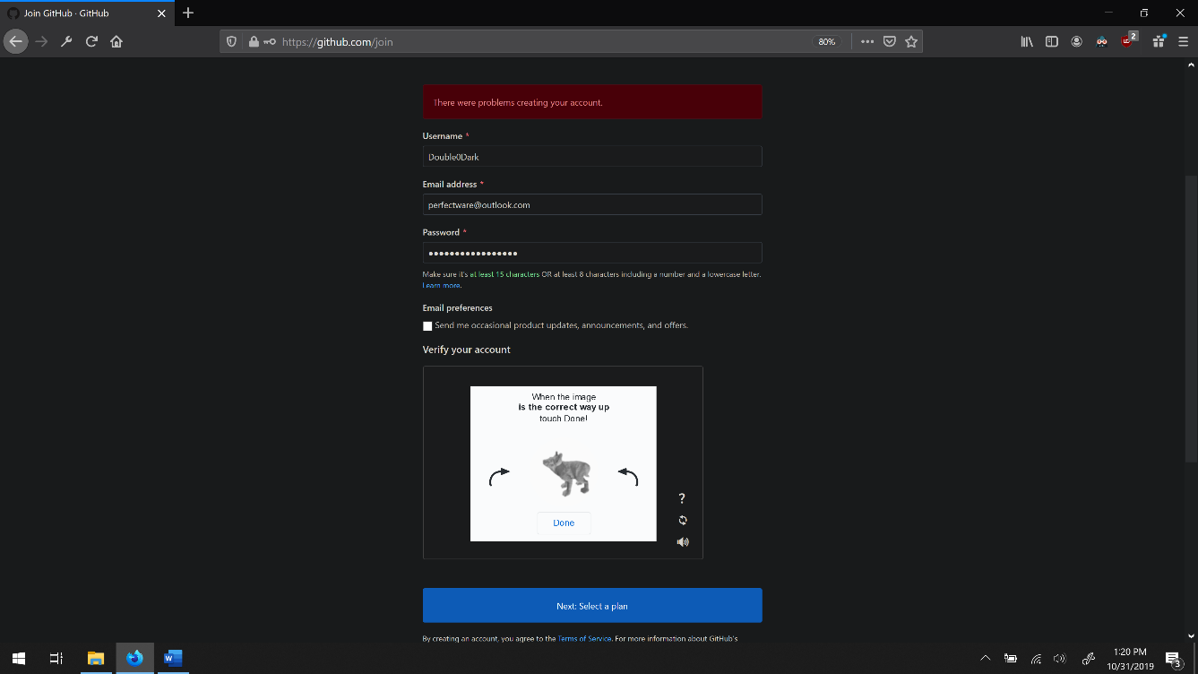

Step 3: Select the free option:

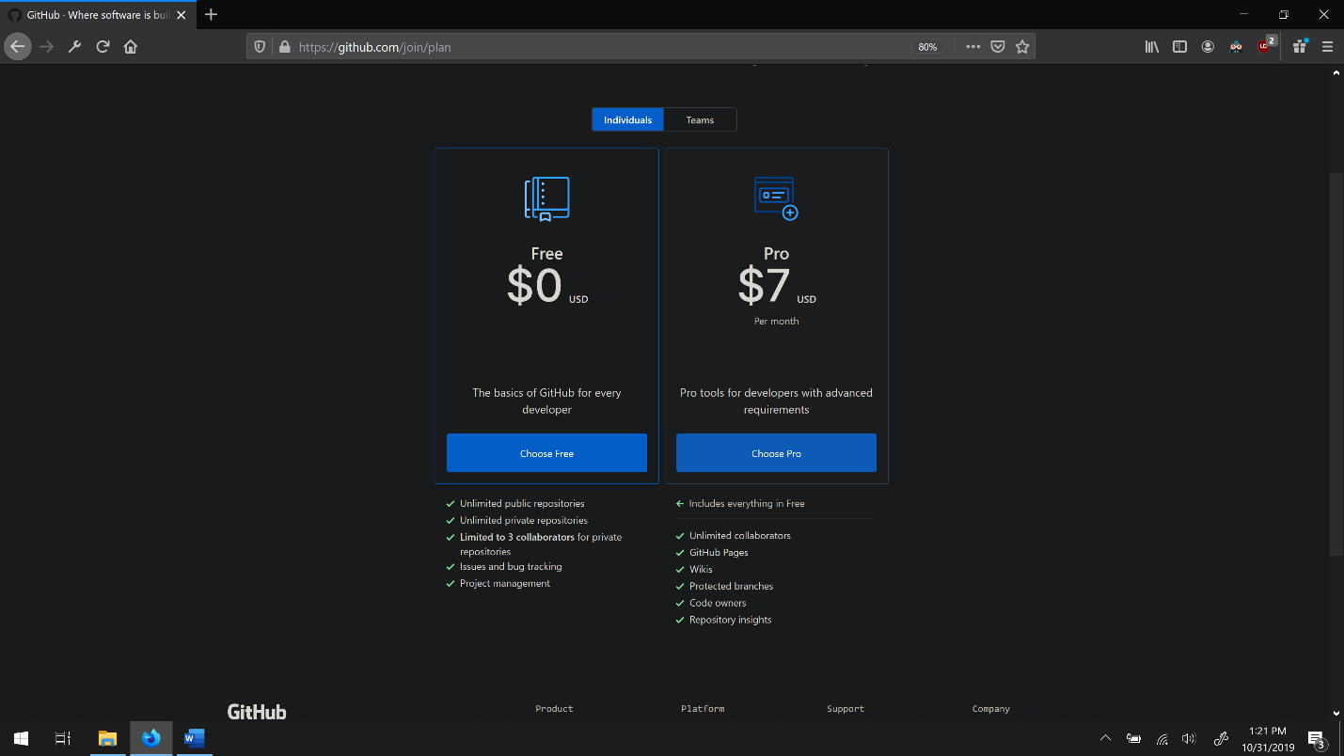

Step 4: Welcome to Github should appear. Select the three pictures of your choosing and press “Complete setup” button. This will prompt you to confirm your email.

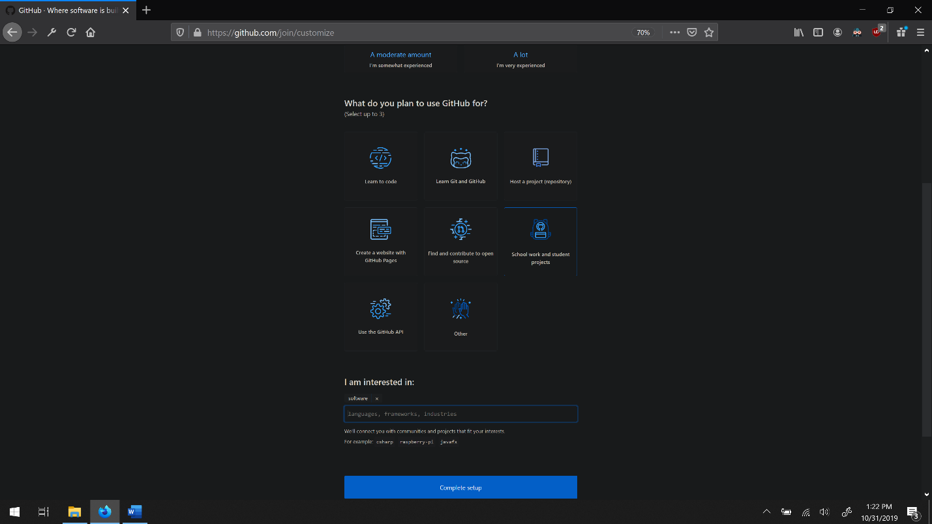

Step 5: Confirm your email:

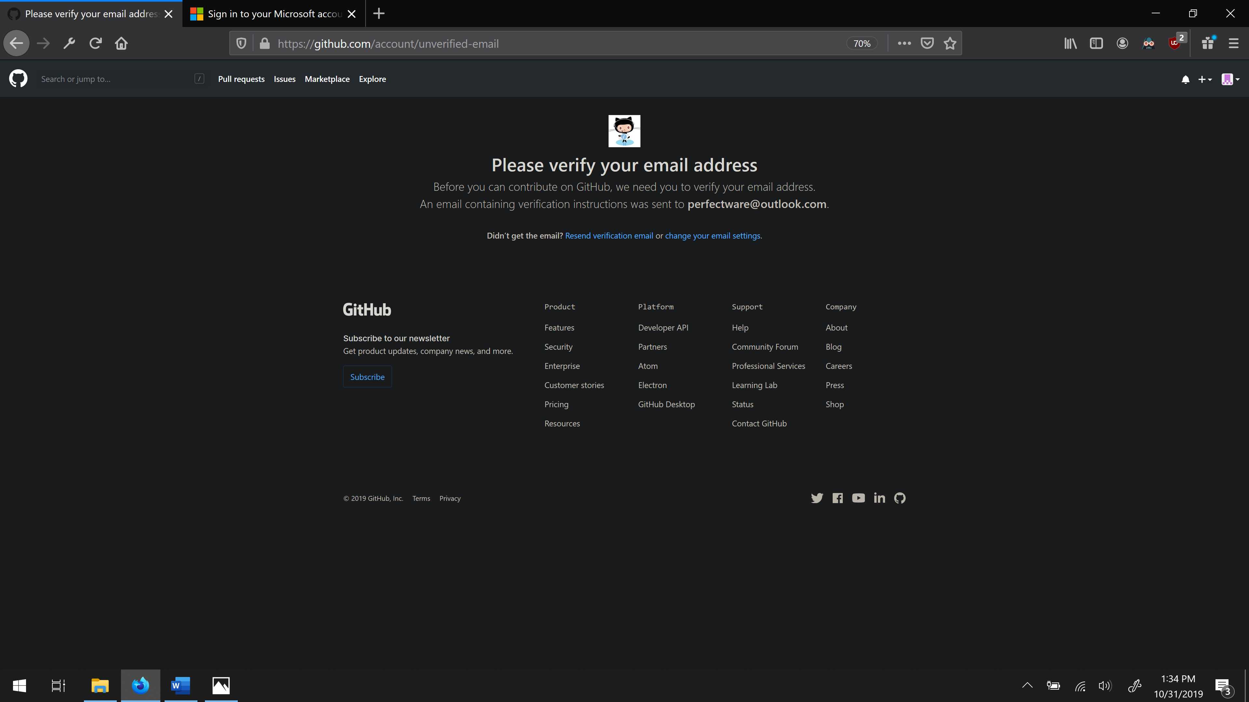

Step 6: Go to your email to confirm:

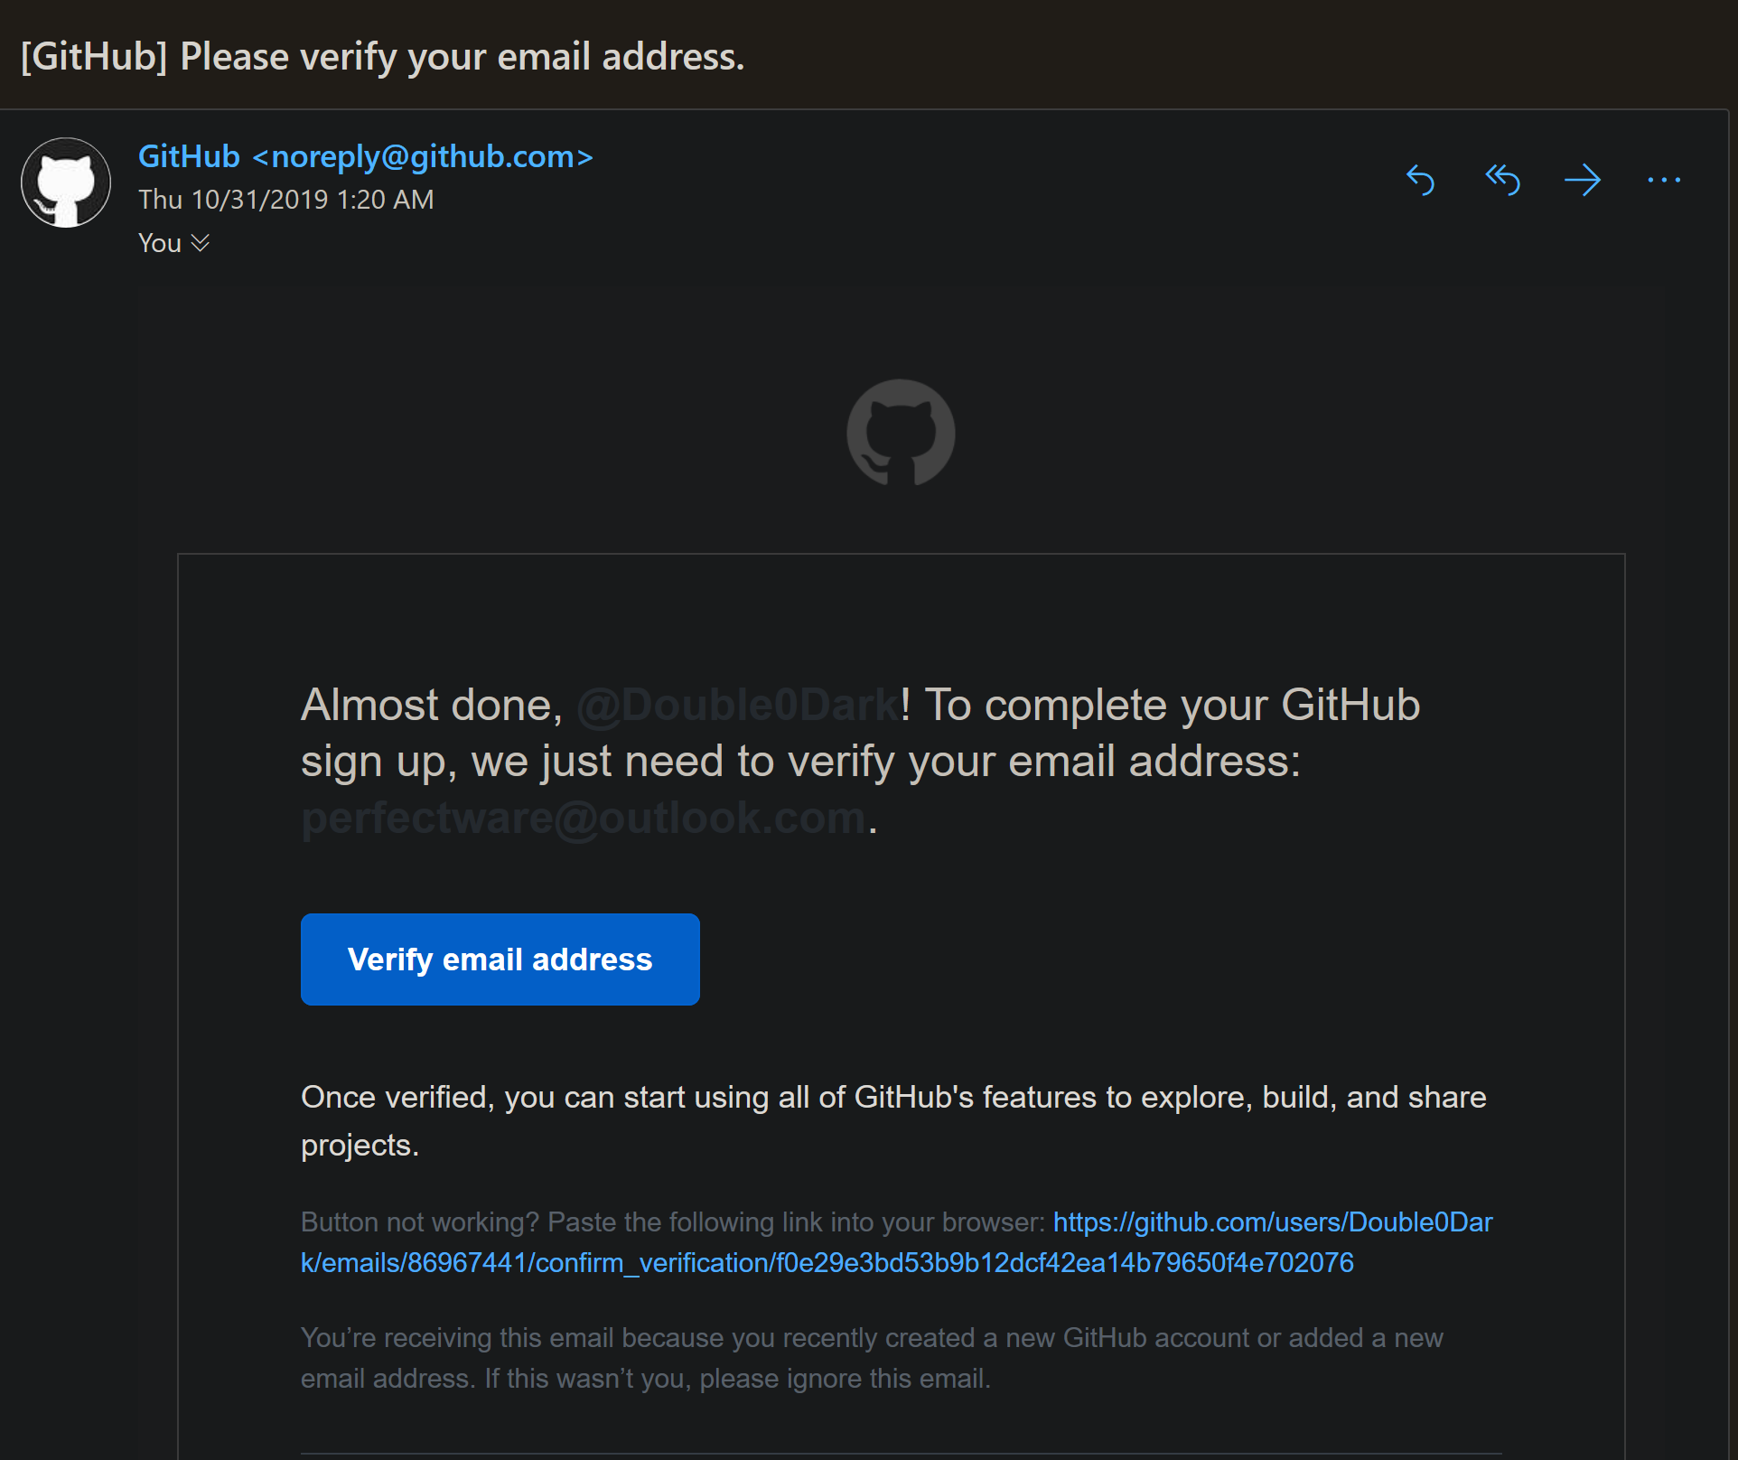

Step 7: If you get this message refresh page and click on your browser URL window where you search for websites.

Step 7.5 If you are not signed in. Sign in:

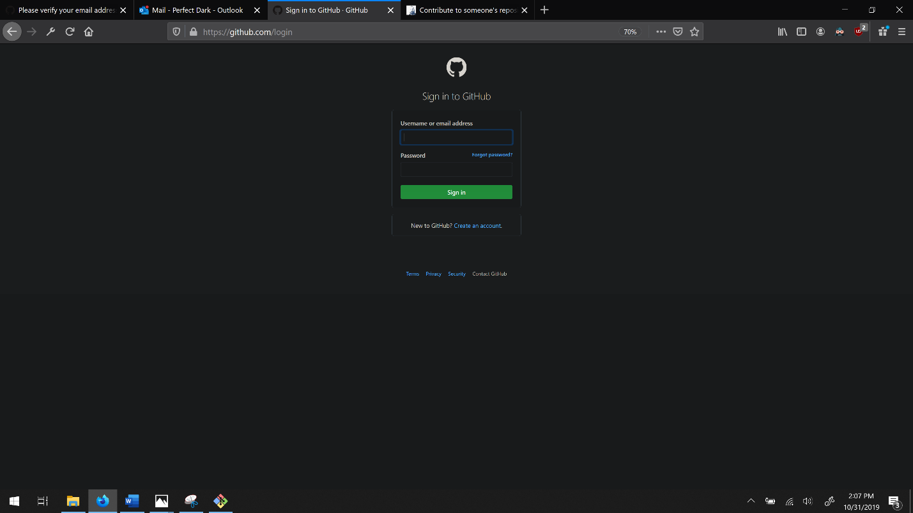

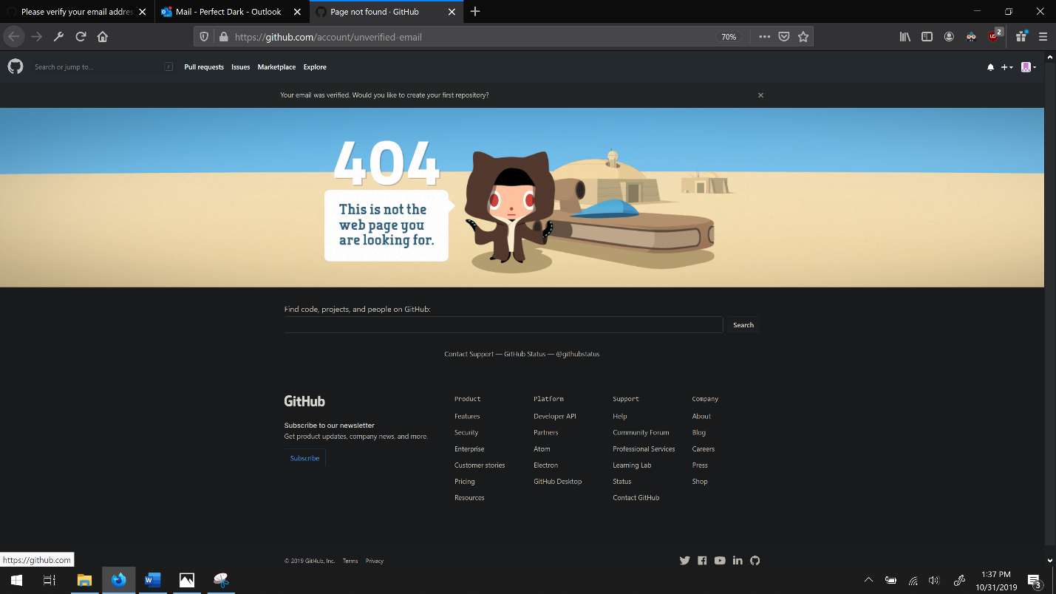

Step 8: Type in: github.com/foxyflow – or /your developers name.

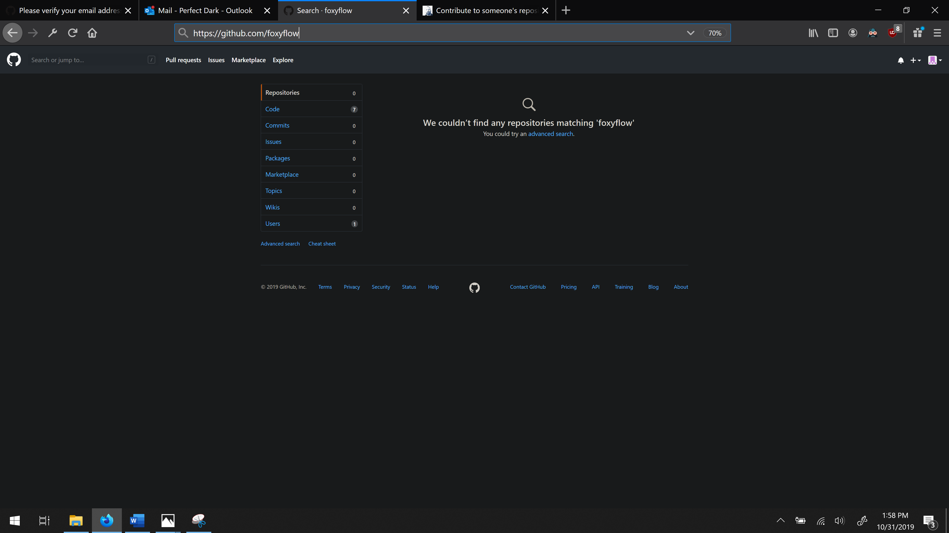

Step 9:

Go to Repositories tab and search for: comp6210-2019-s2-tg-assn2-foxyflow

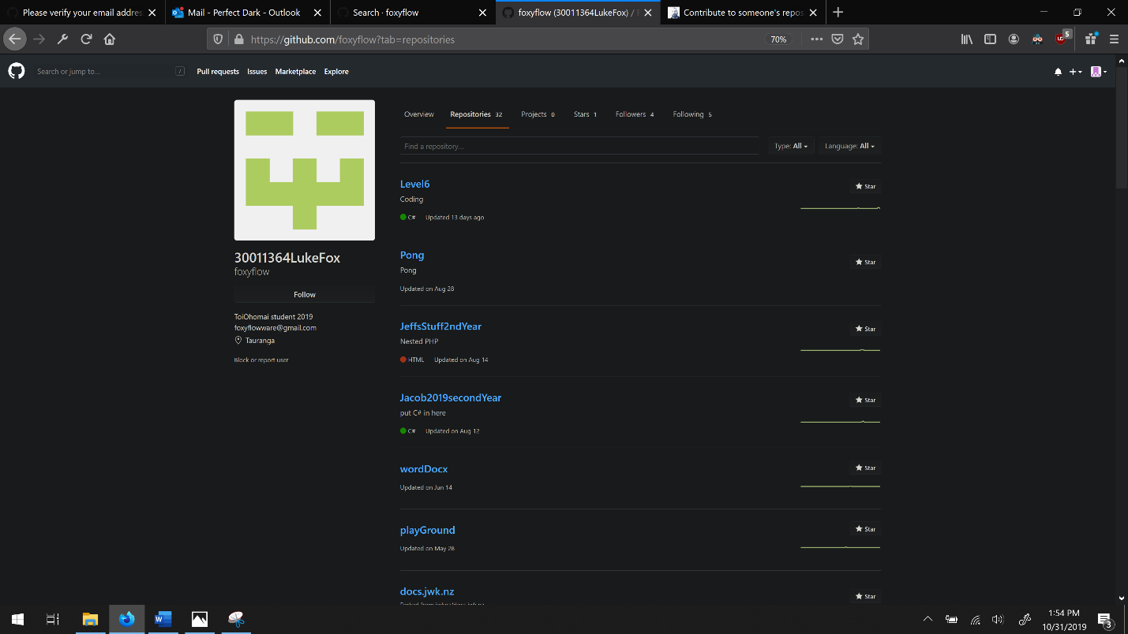

Step 10: After finding comp6201-2019-s2-tg-assn2-foxyflow click on it then the green Clone or download button. Copy the link

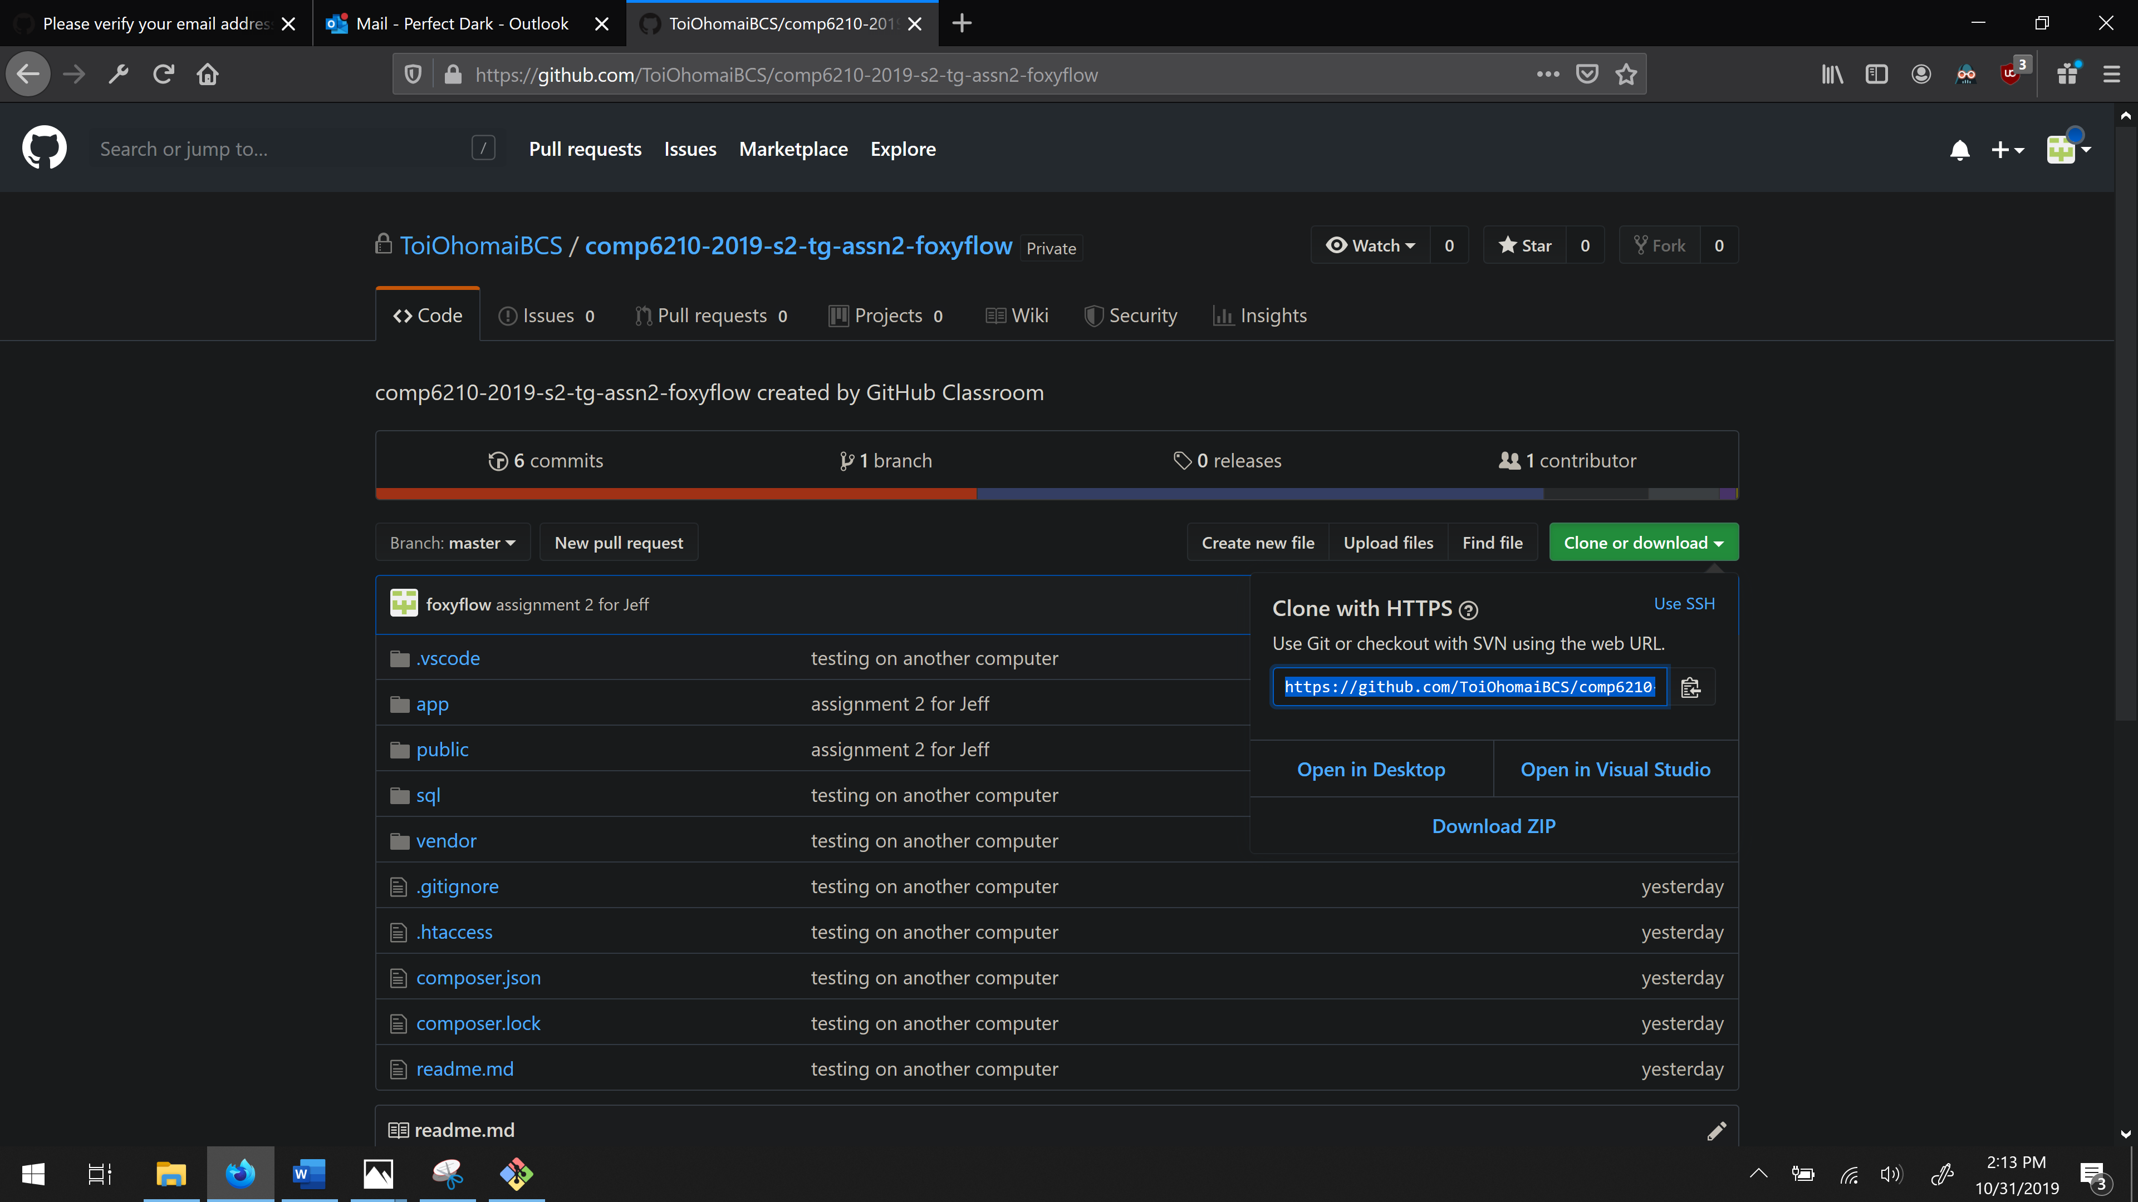

Step 11: Get Gitbash installed. (You said you had a windows computer so these instructions are for a Windows operating system installed on your computer)

**If you have Gitbash installed – go to Step 22.**

Go to gitforwindows.org (if the logo is red, hover over it to match the screenshot).

Click download.

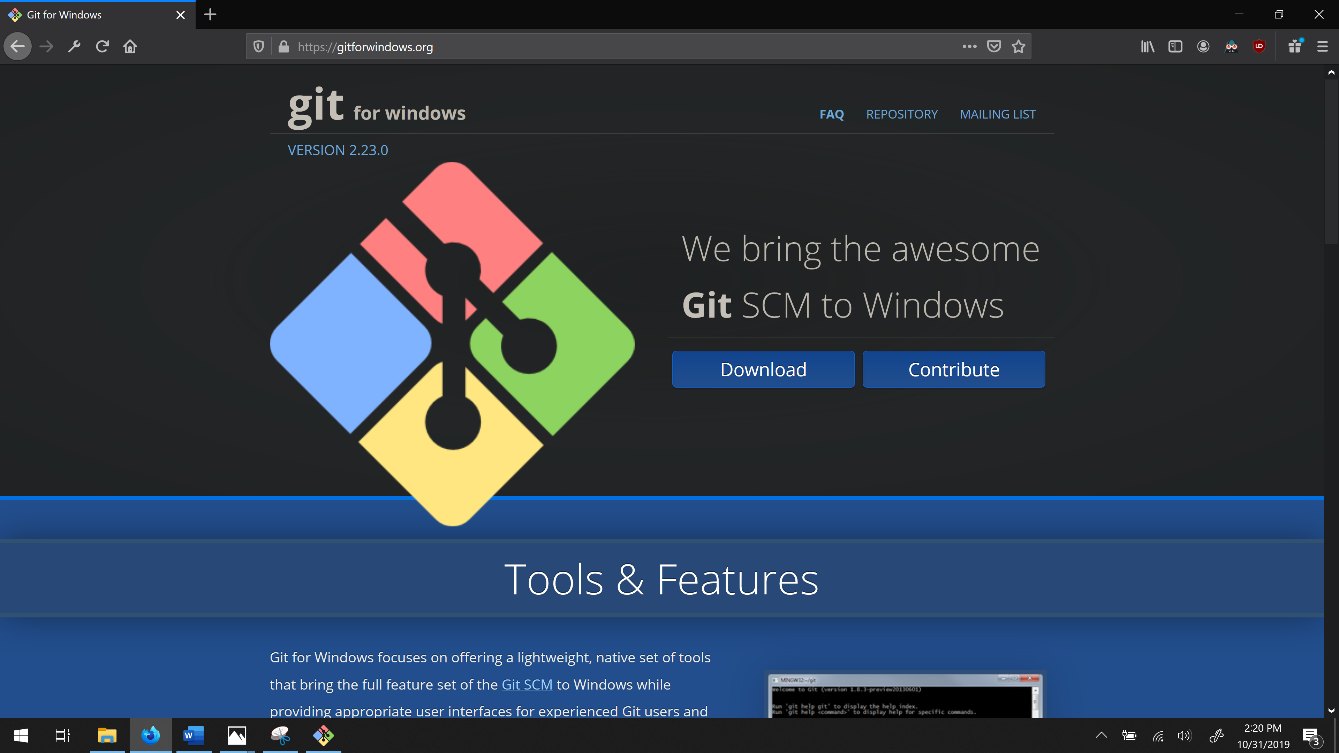

Step 12: Save file to downloads or your special location. (Warning, white screens will appear and may hurt your eyes.)

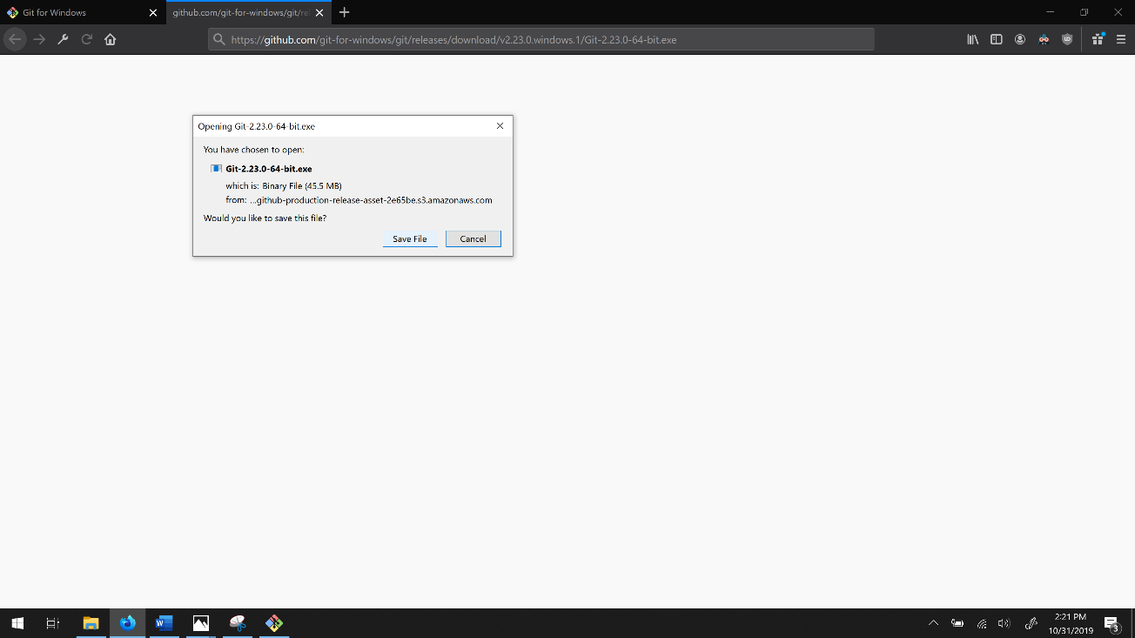

Step 12 continued: This tutorial has chosen to save to downloads.

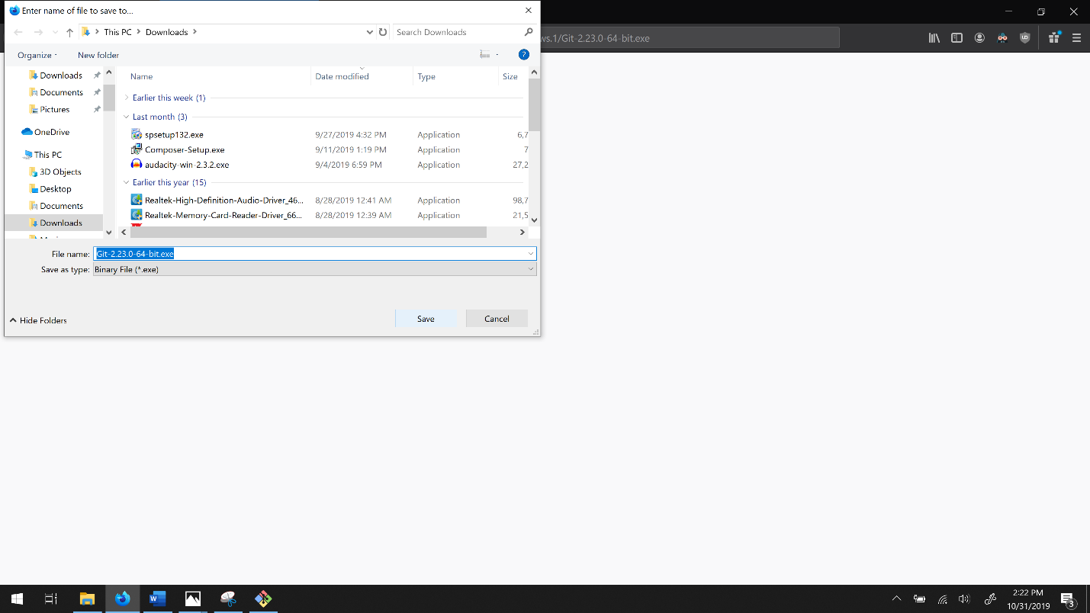

Step: 13: Important: Read all of the terms and conditions, slowly, line by line to make sure there is no ticked windows for malware to be installed. Click Next.

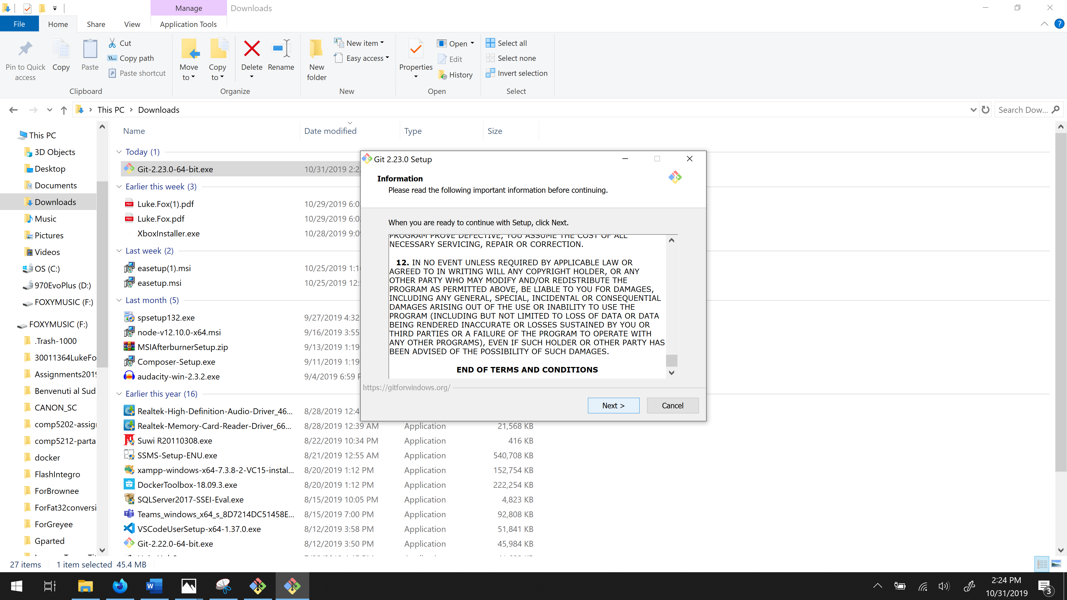

Step 14: Click next with these windows ticked.

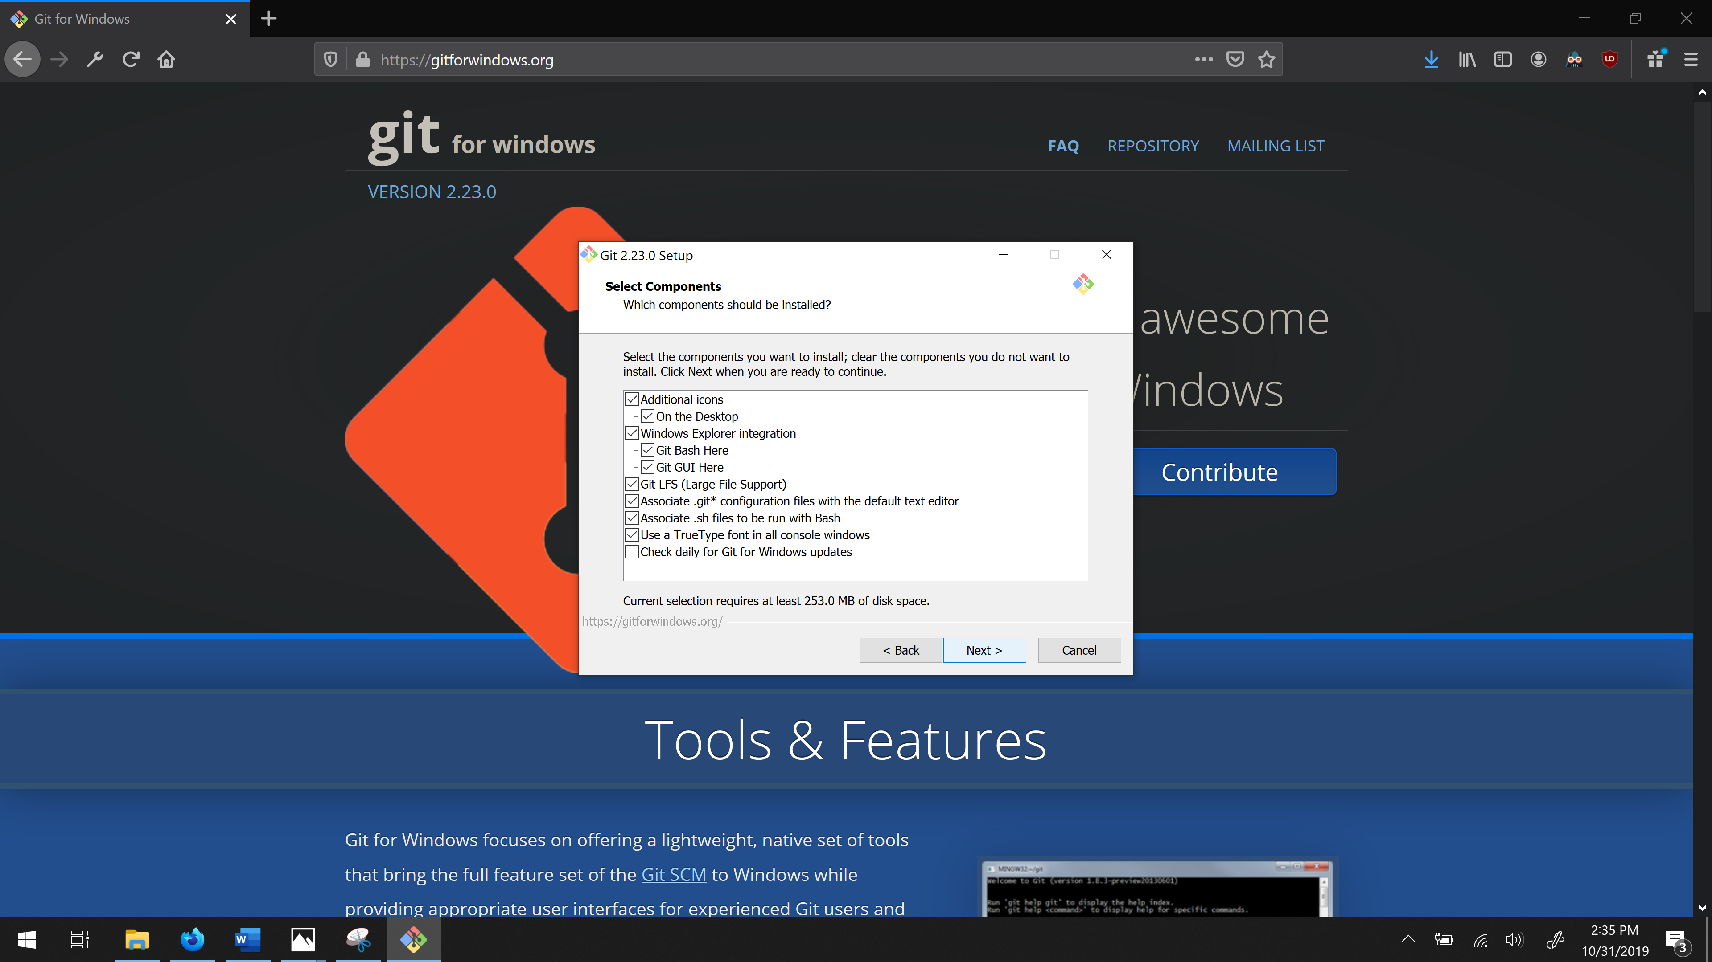

Step 15: Click next again. This allows gitbash to communicate with Visual Studio Code – An IDE with colourful text to make reading some text easier (and more).

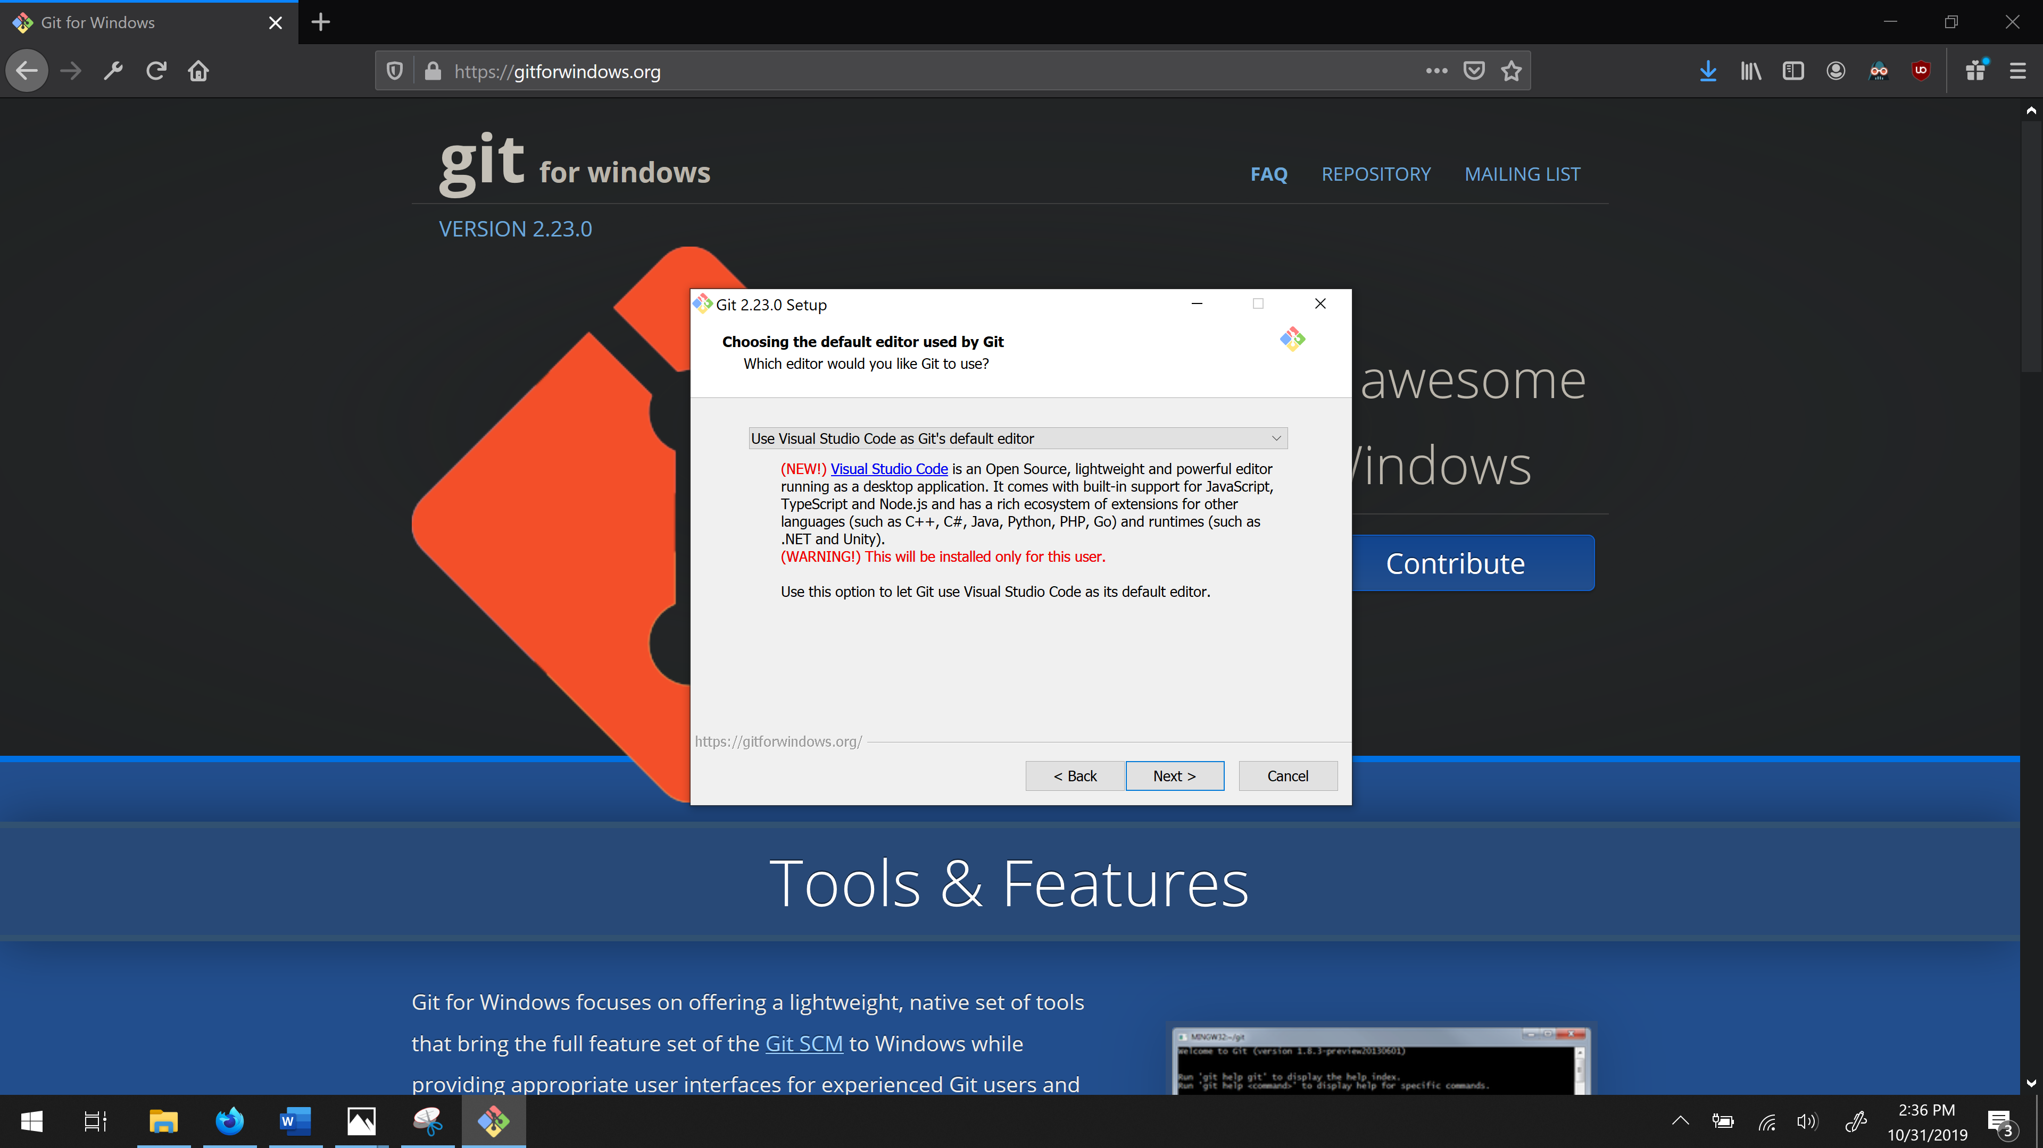

Step 16: Click next

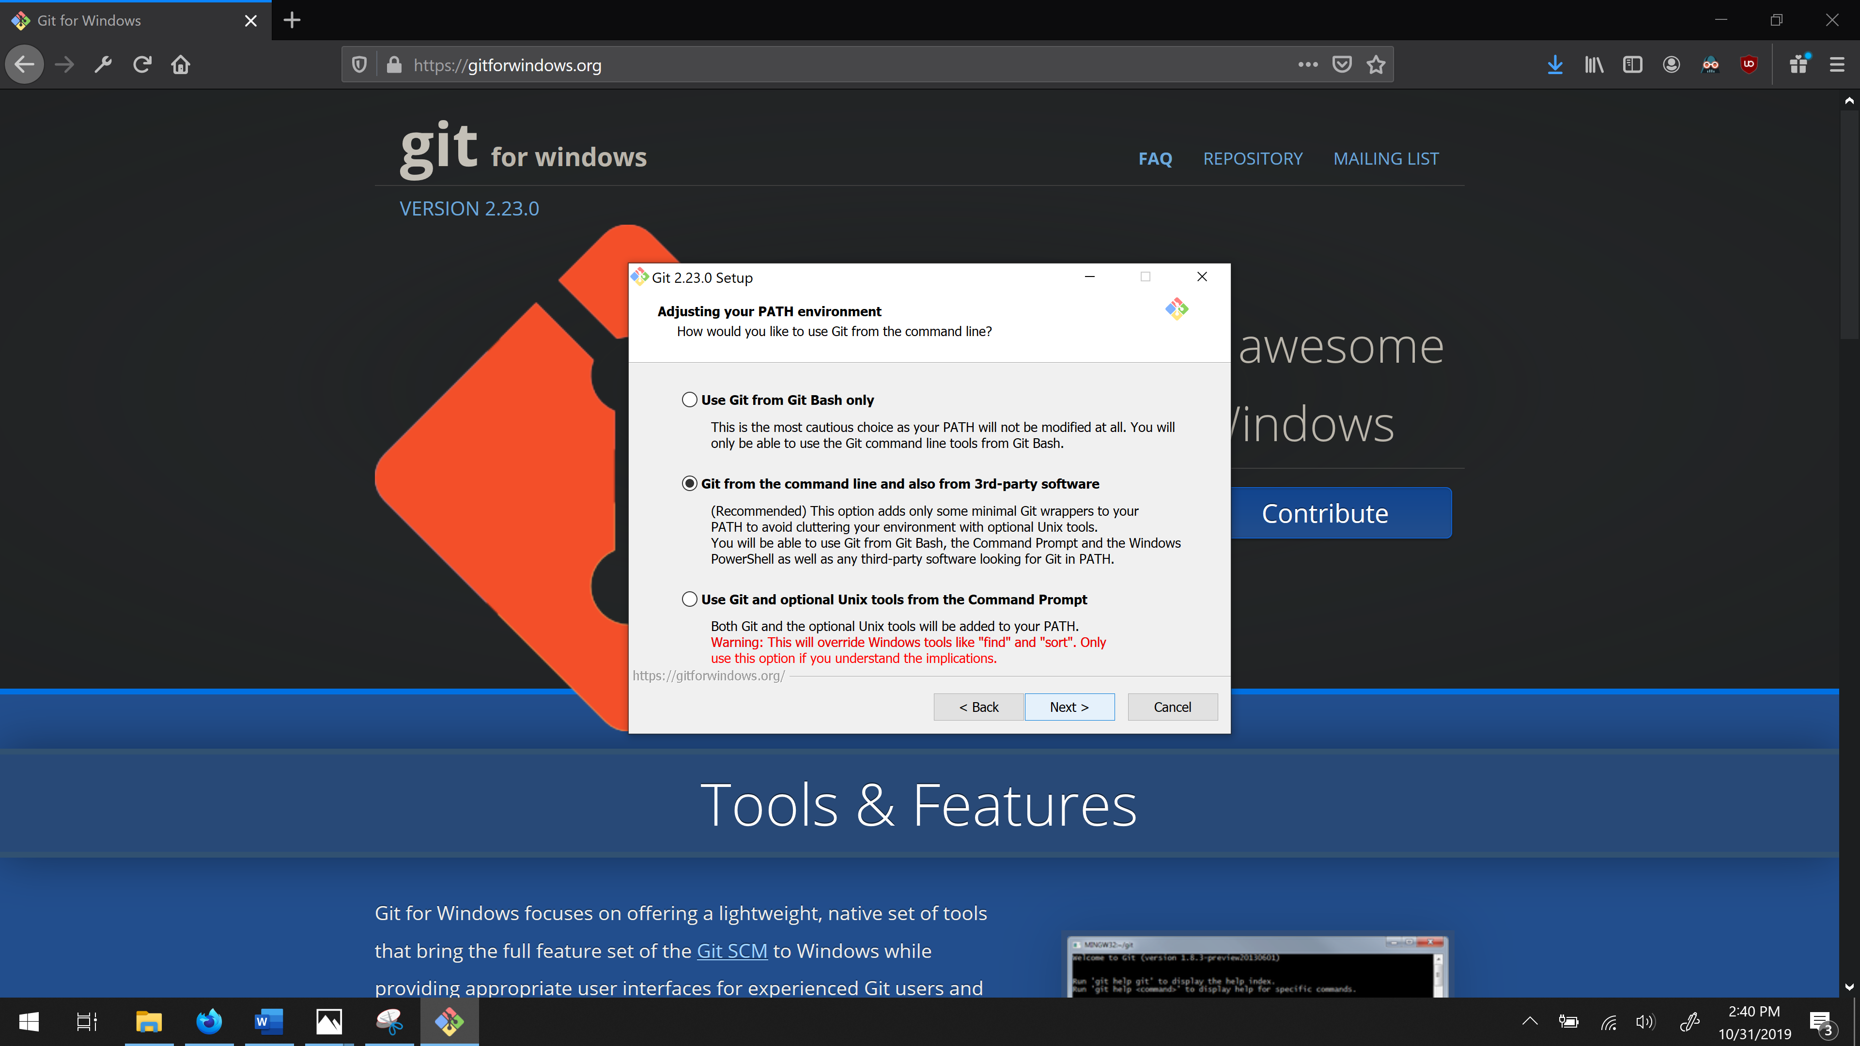

Step 17: Click Next.

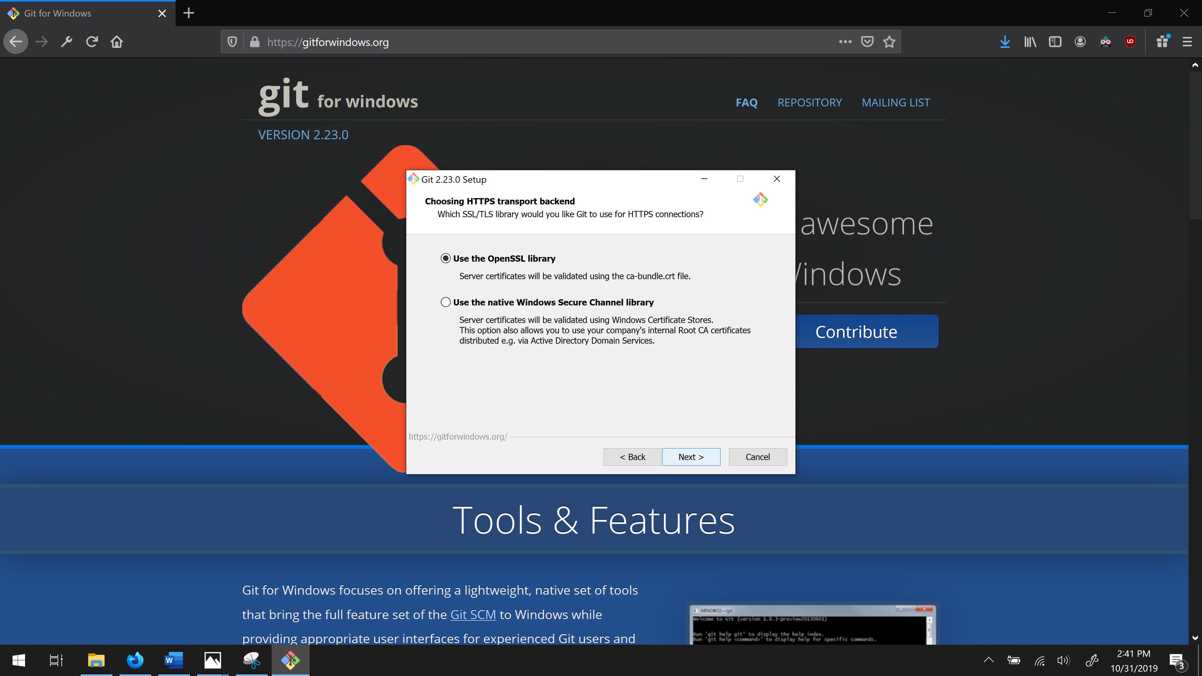

Step 18: Click Next: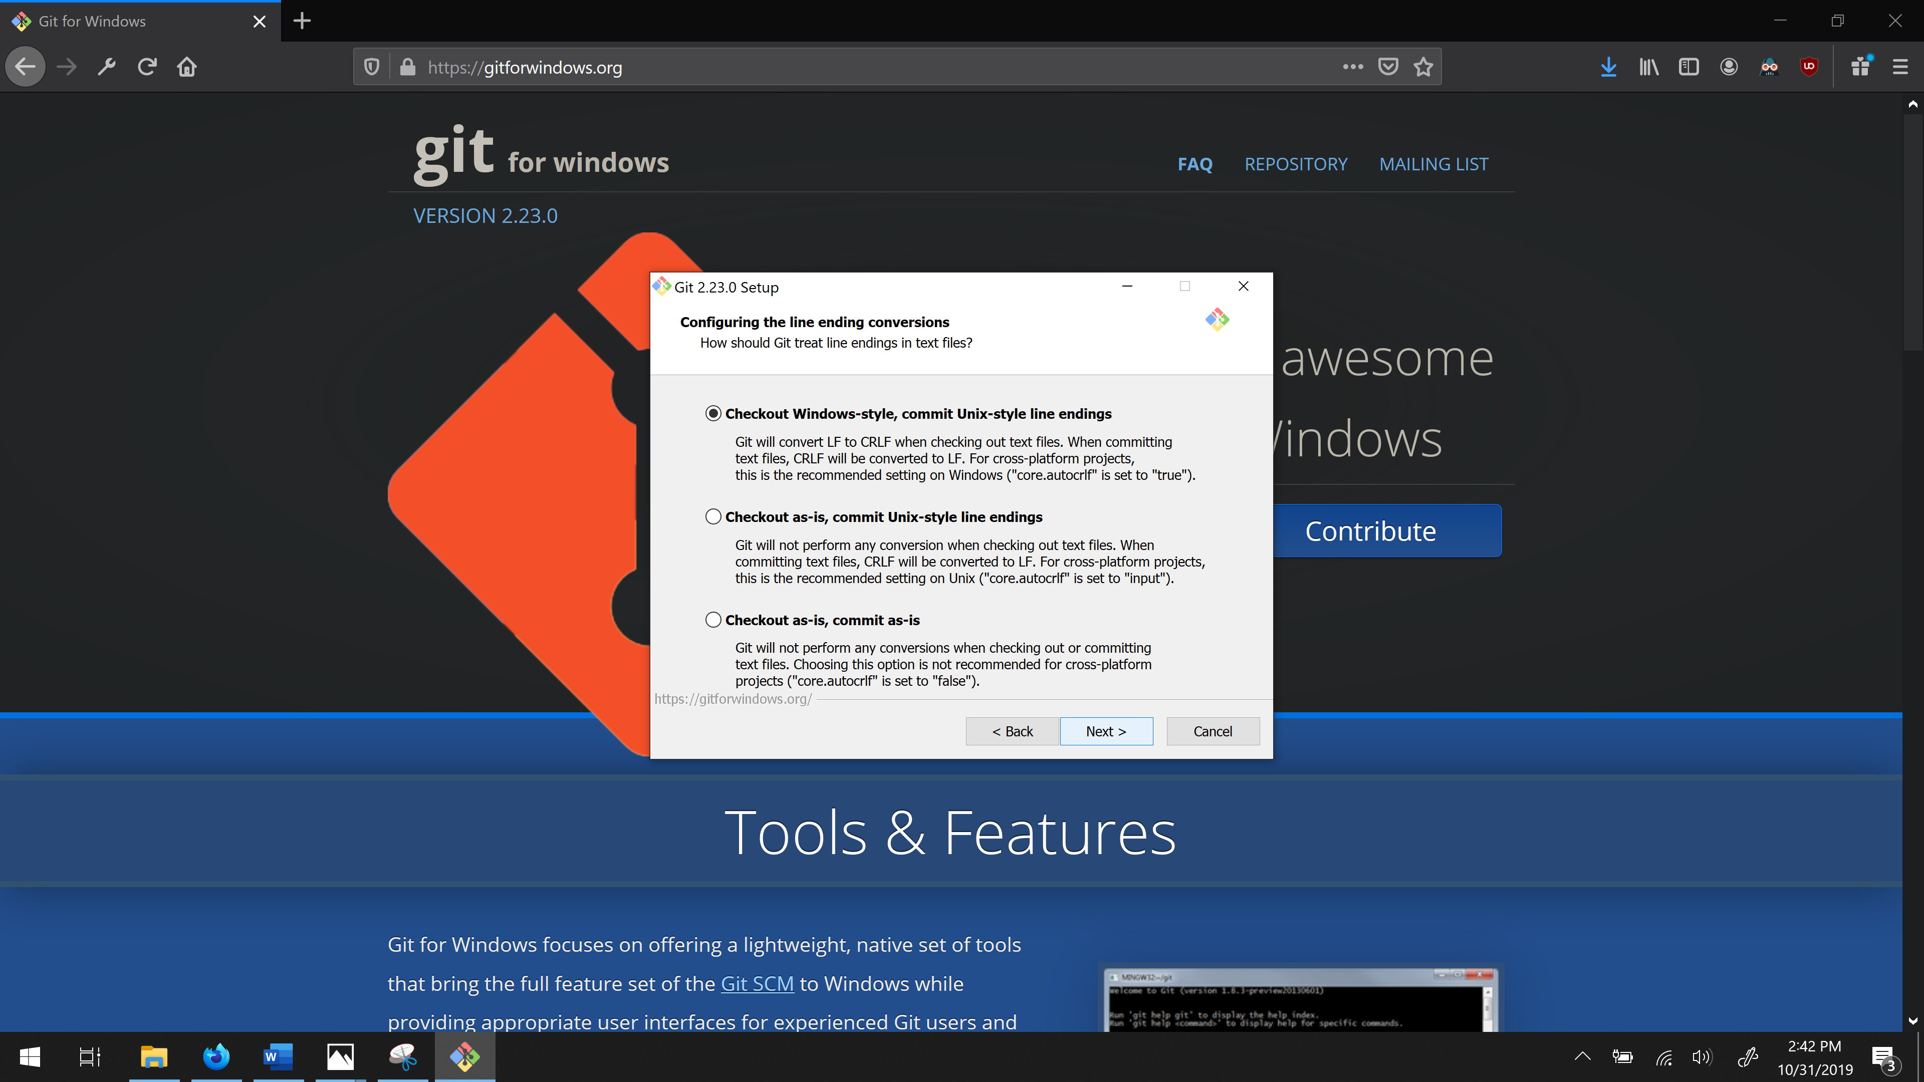

Step 19: Click … Next.

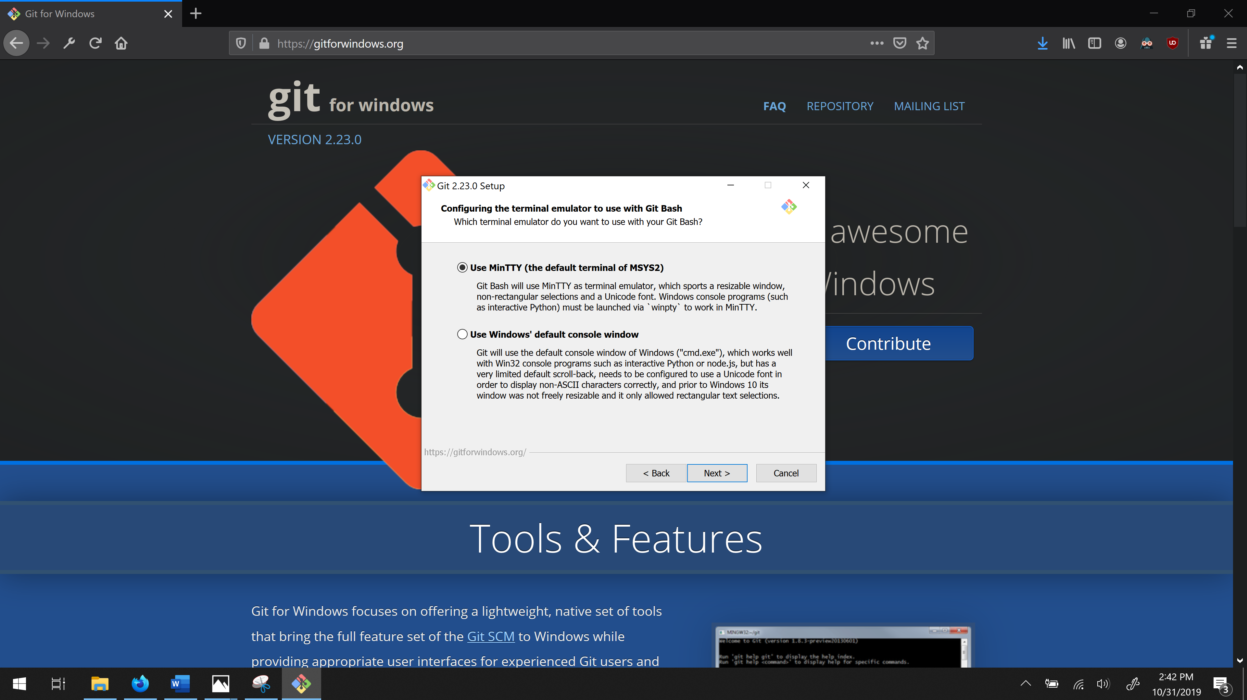

Step 20: Click Next.

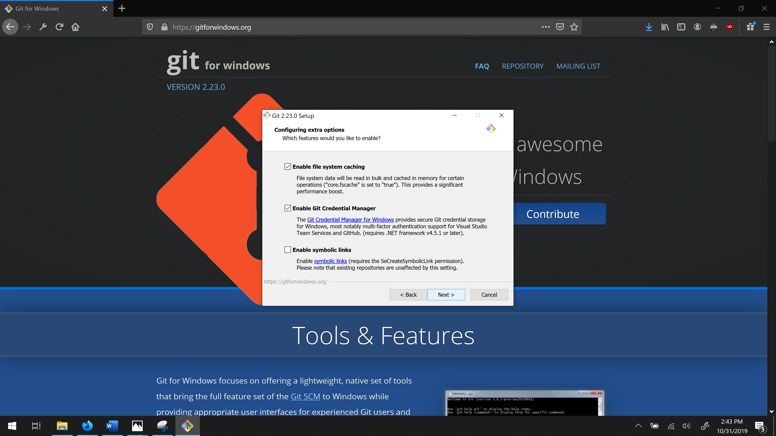

Step 21: Click Next to install

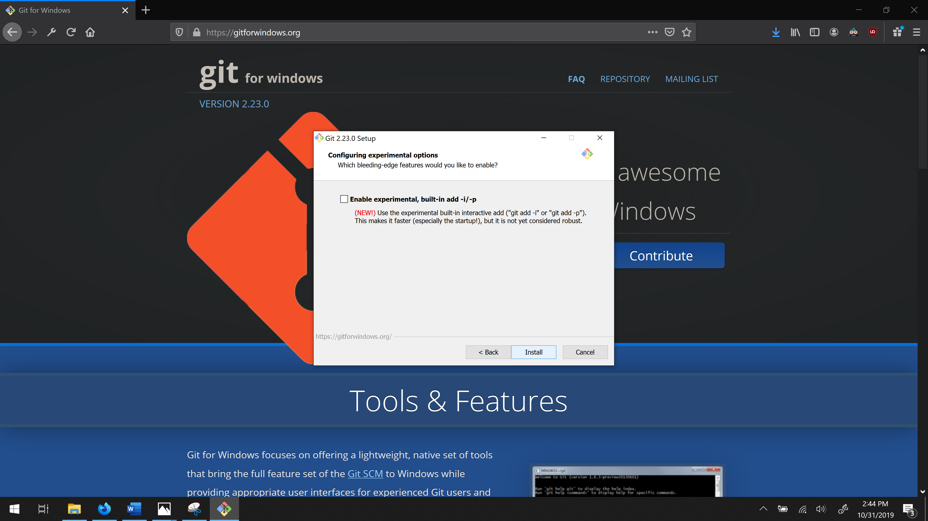

Step 22: To use gitbash: Right click on your desktop or if you have XAMPP installed, right click in your htdocs folder where you installed it and open gitbash.

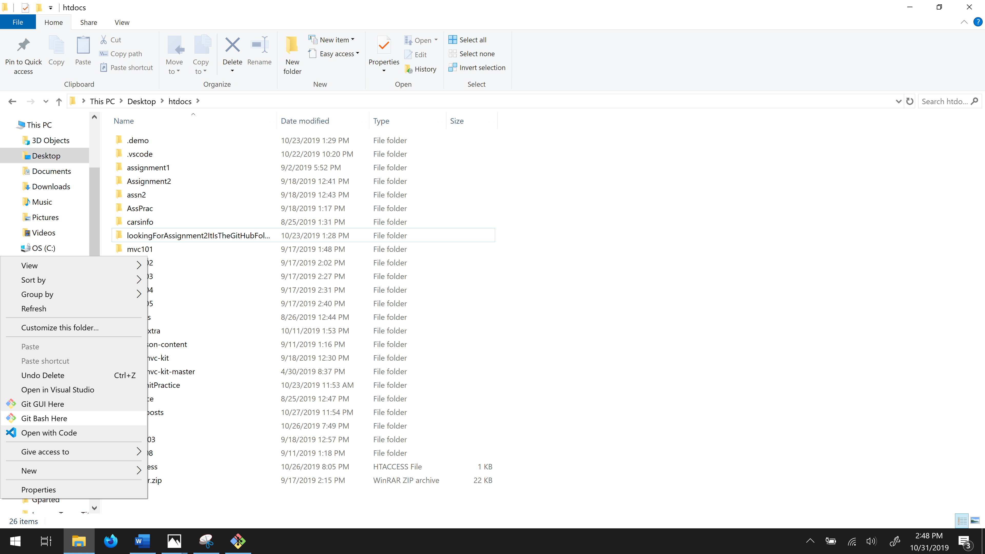

Step 23: Type in: git clone then hold Shift and press Insert to paste in the git repository from Github. Press Enter. (This may take a few minutes.)

Next setting up XAMPP. If you have XAMPP go to Step 26.

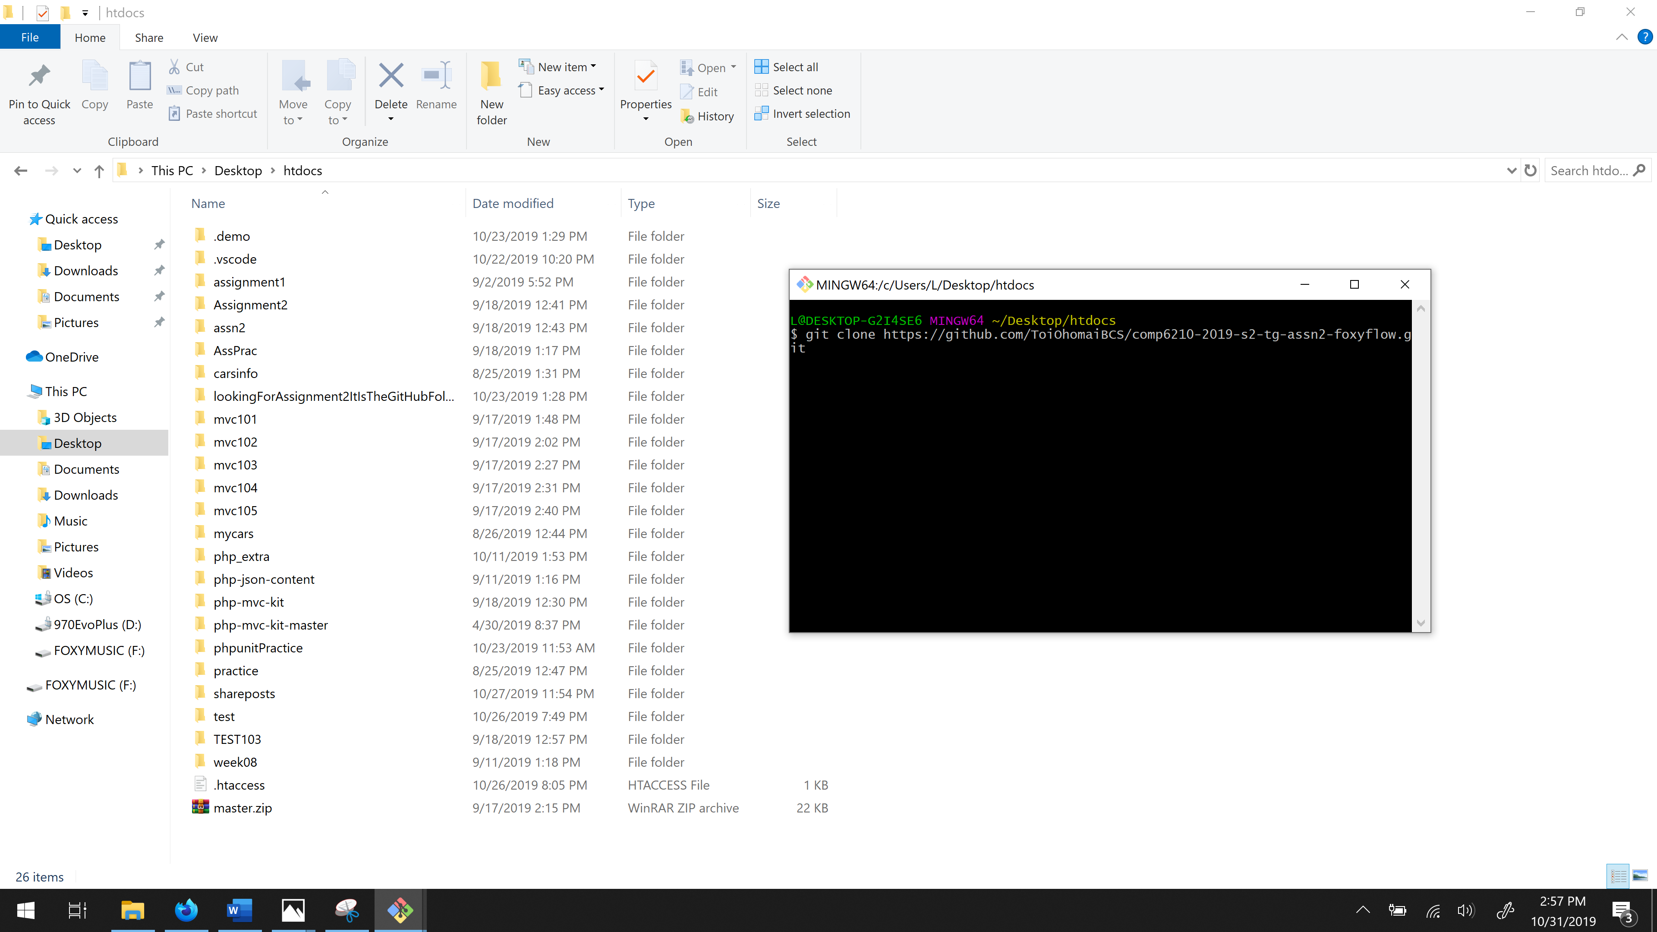

Step 24: Installing X-AMPP. While the folder with your website is being uploaded, install XAMPP is you have not got it: Go to: apachefriends.org

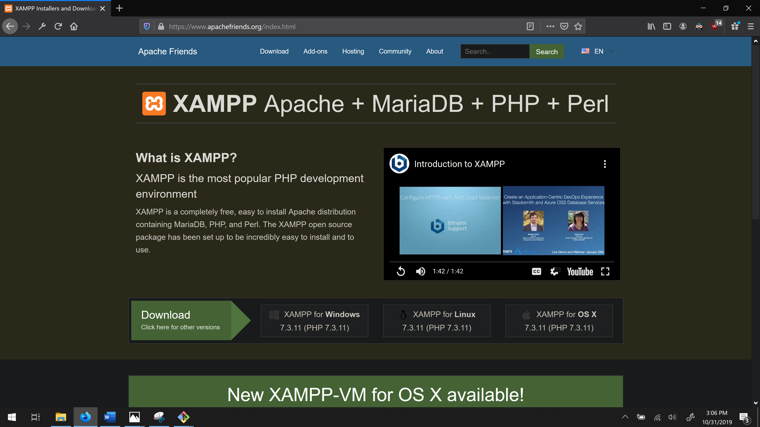

Step 25: Watch the video on the home screen to install XAMPP. Or just click download, go to downloads and follow the prompts to install. Step 26: Open XAMPP

Go to your C-drive click on XAMPP and then click on the XAMPP Control. This will bring up the XAMPP control panel. Click Config, Apache (http.conf)

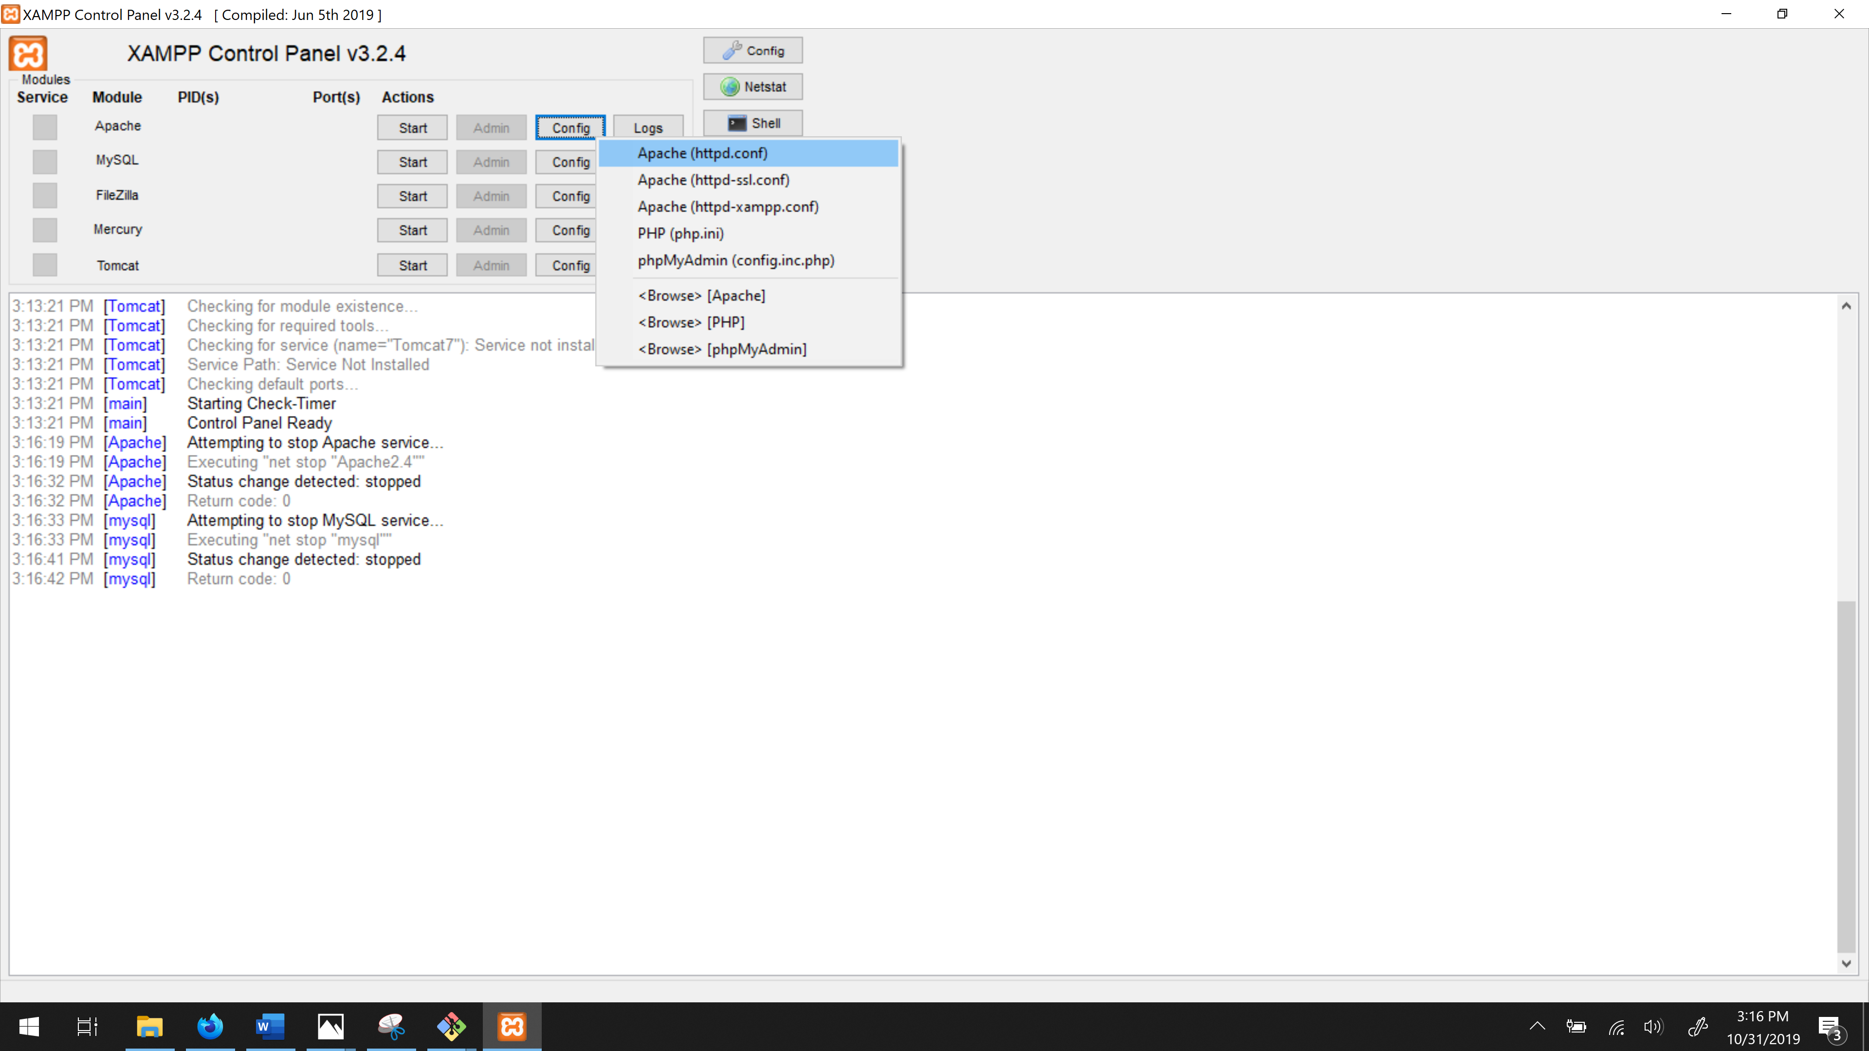

Step 27: Changing the ports. I have set the port number to 9080.

**You must change these if different.**

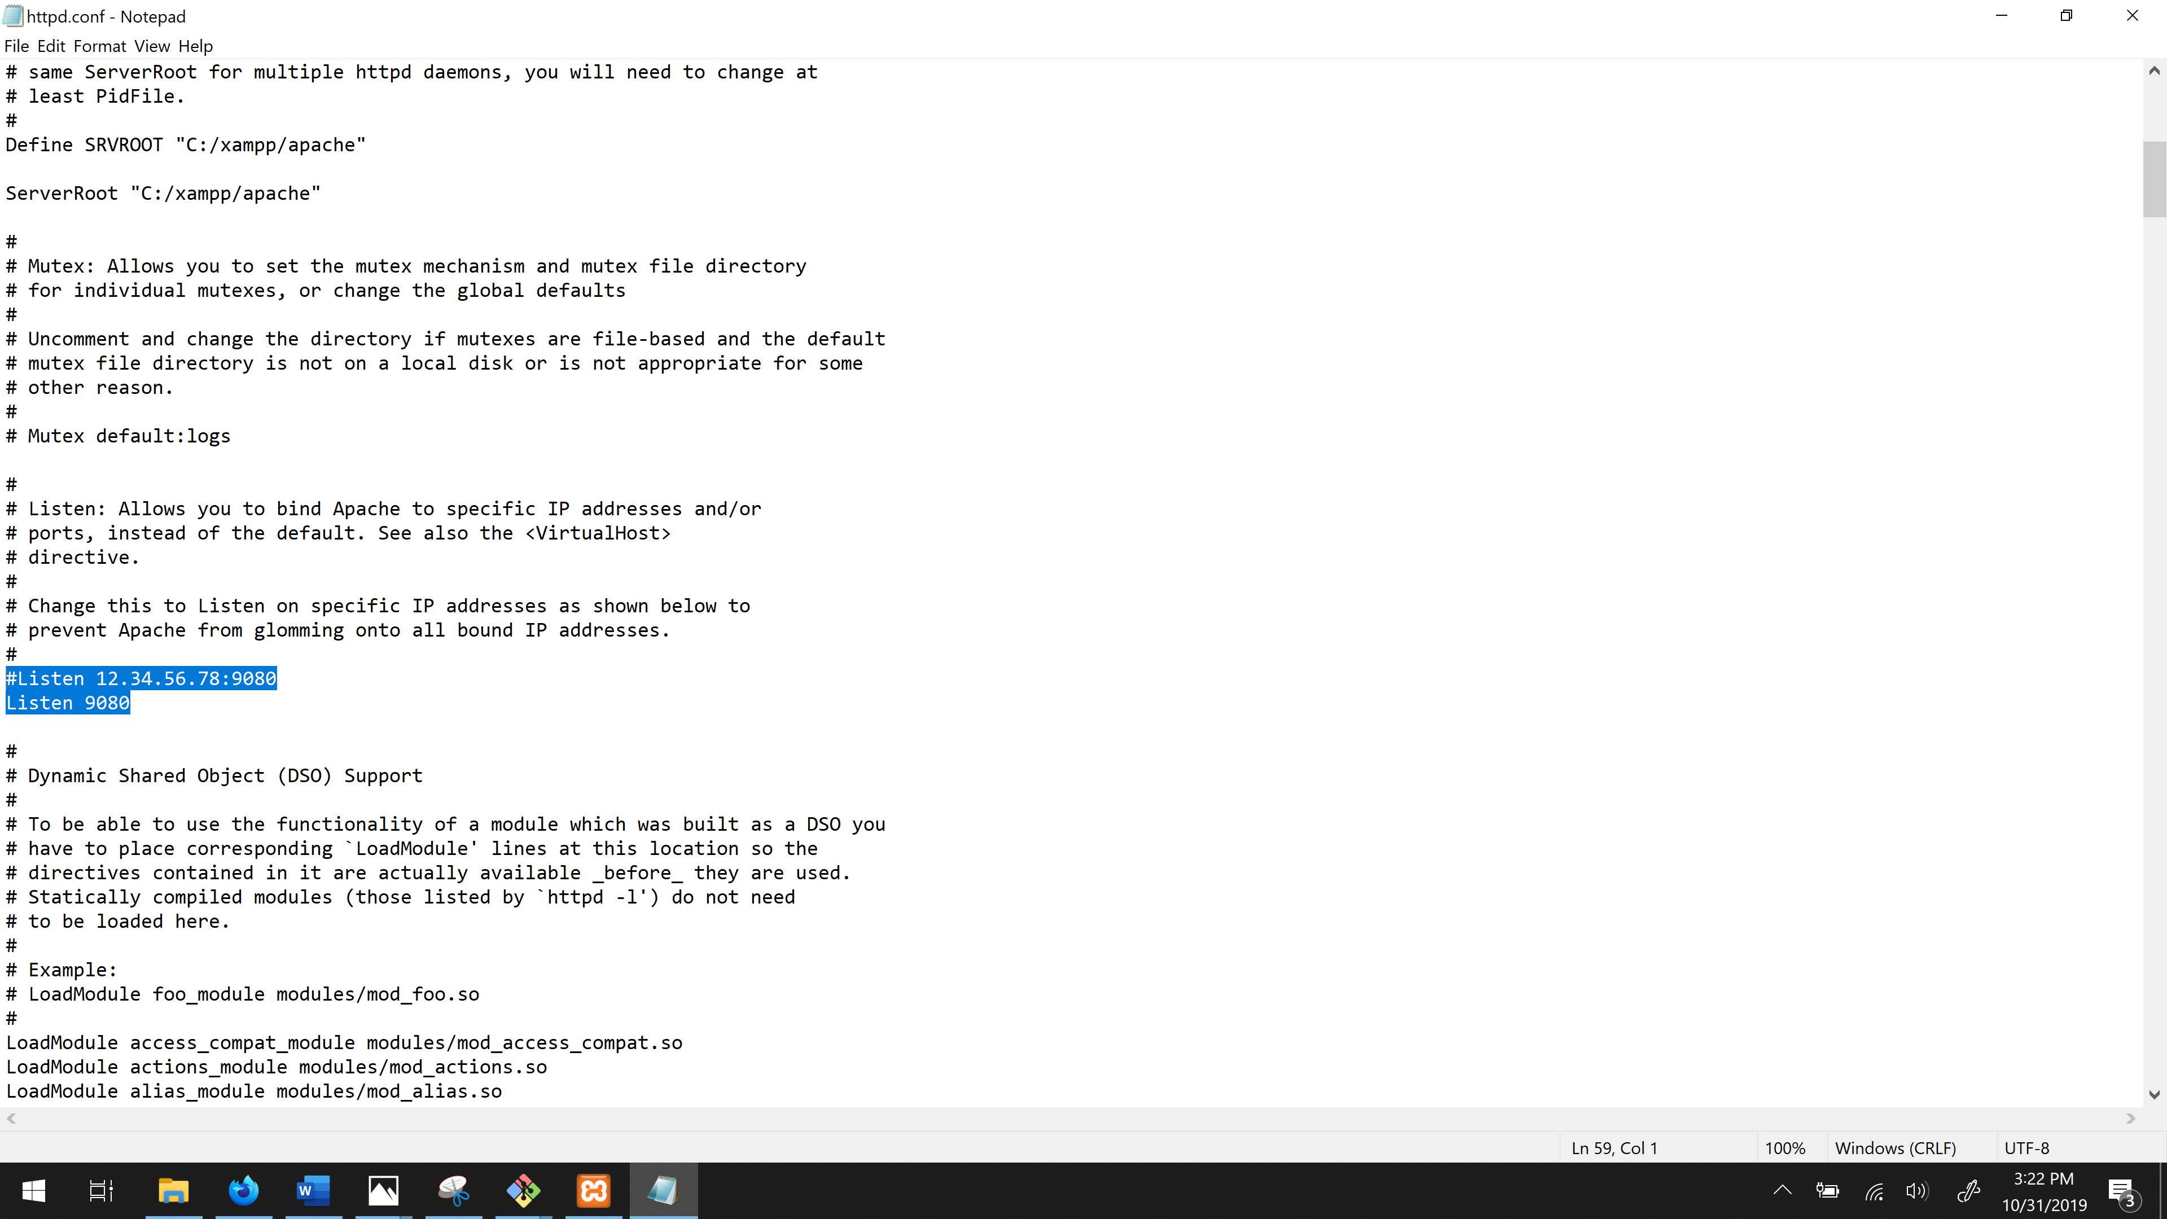

Scroll down a bit further: Make sure this matches localhost:9080

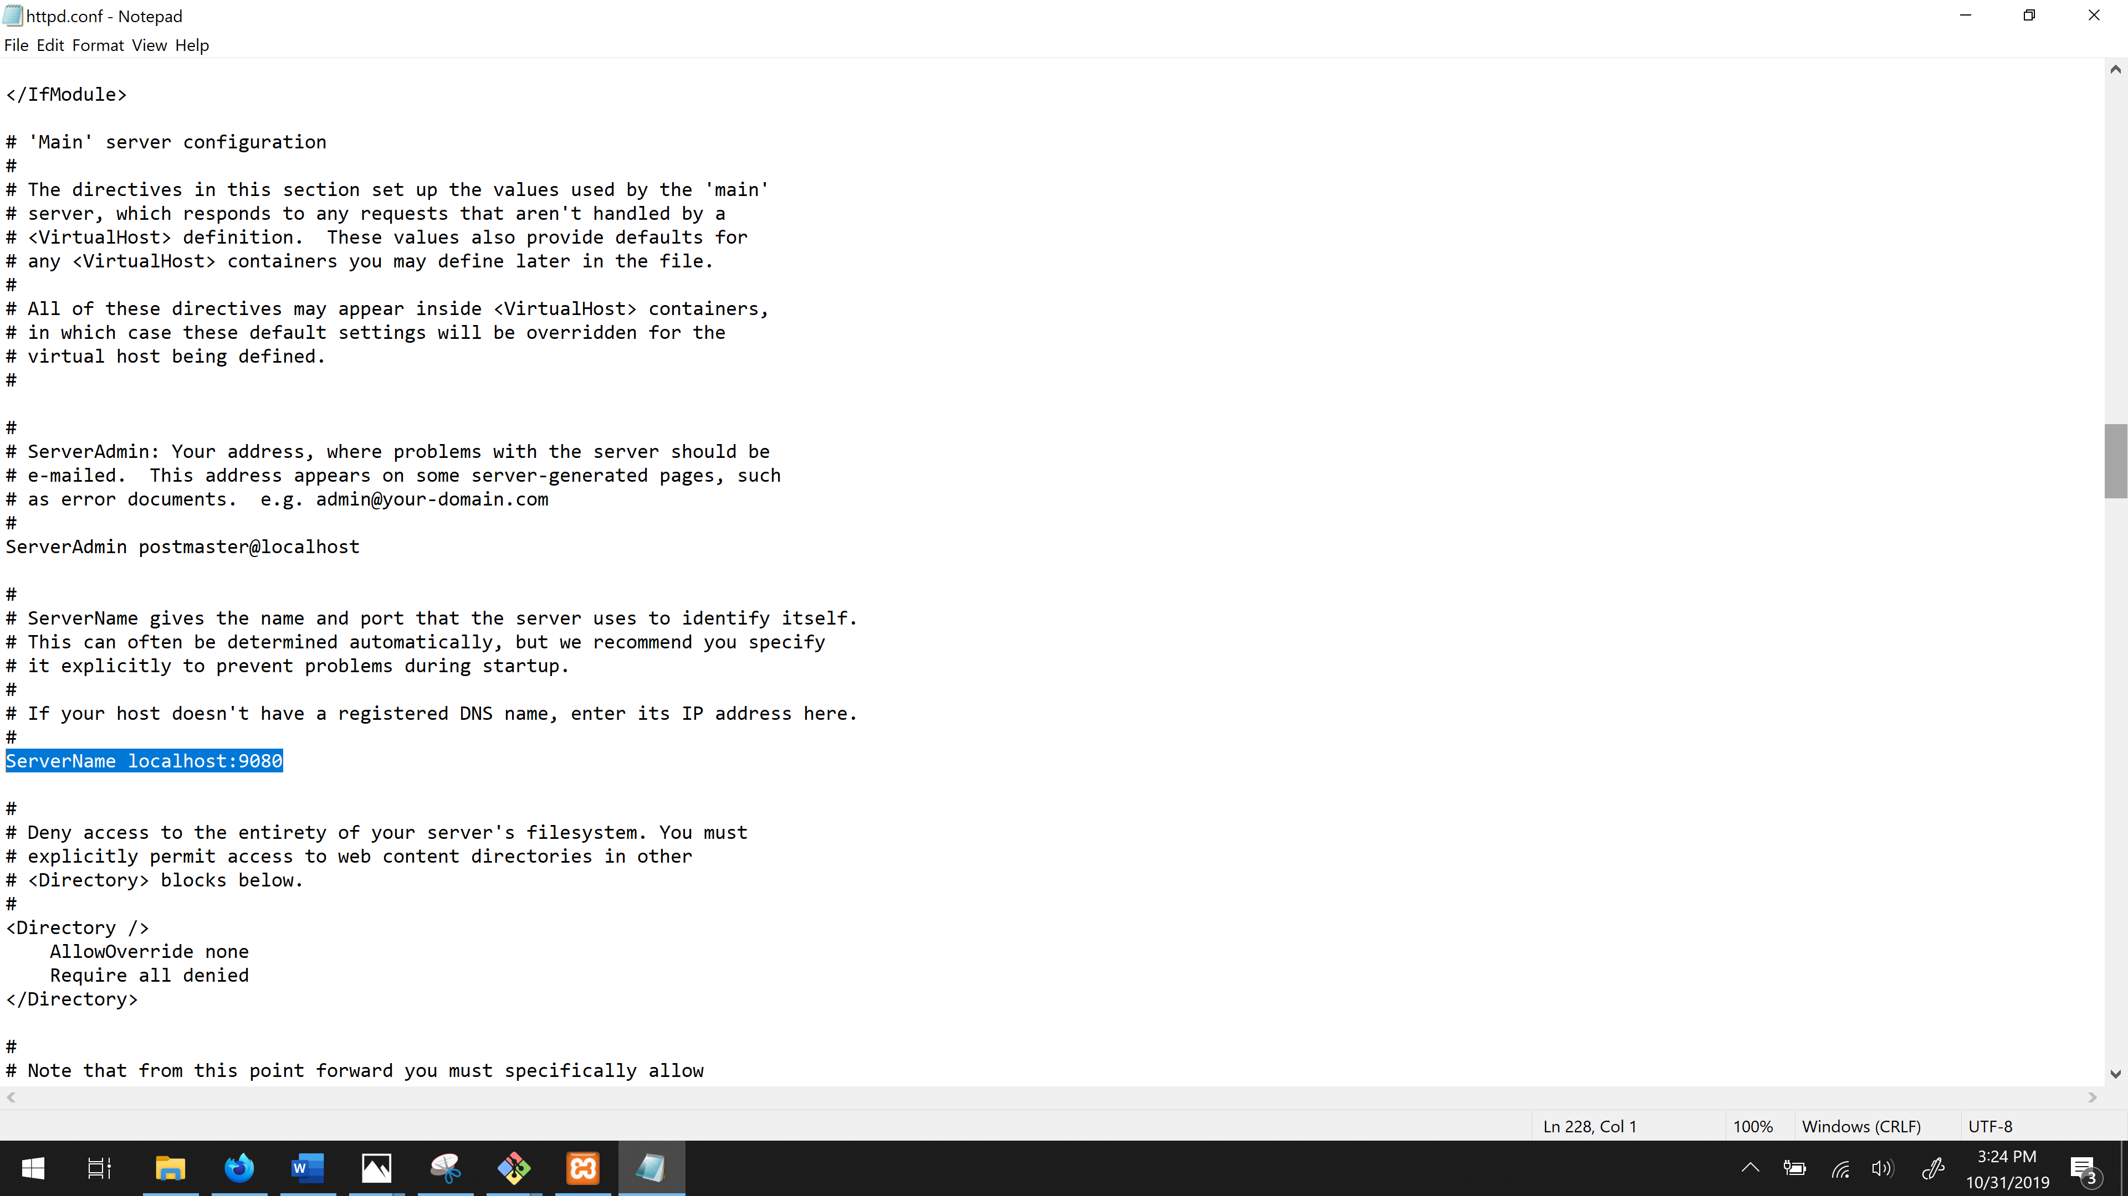

Step 28: Press start on Apache. If this does not work. Run as Administrator: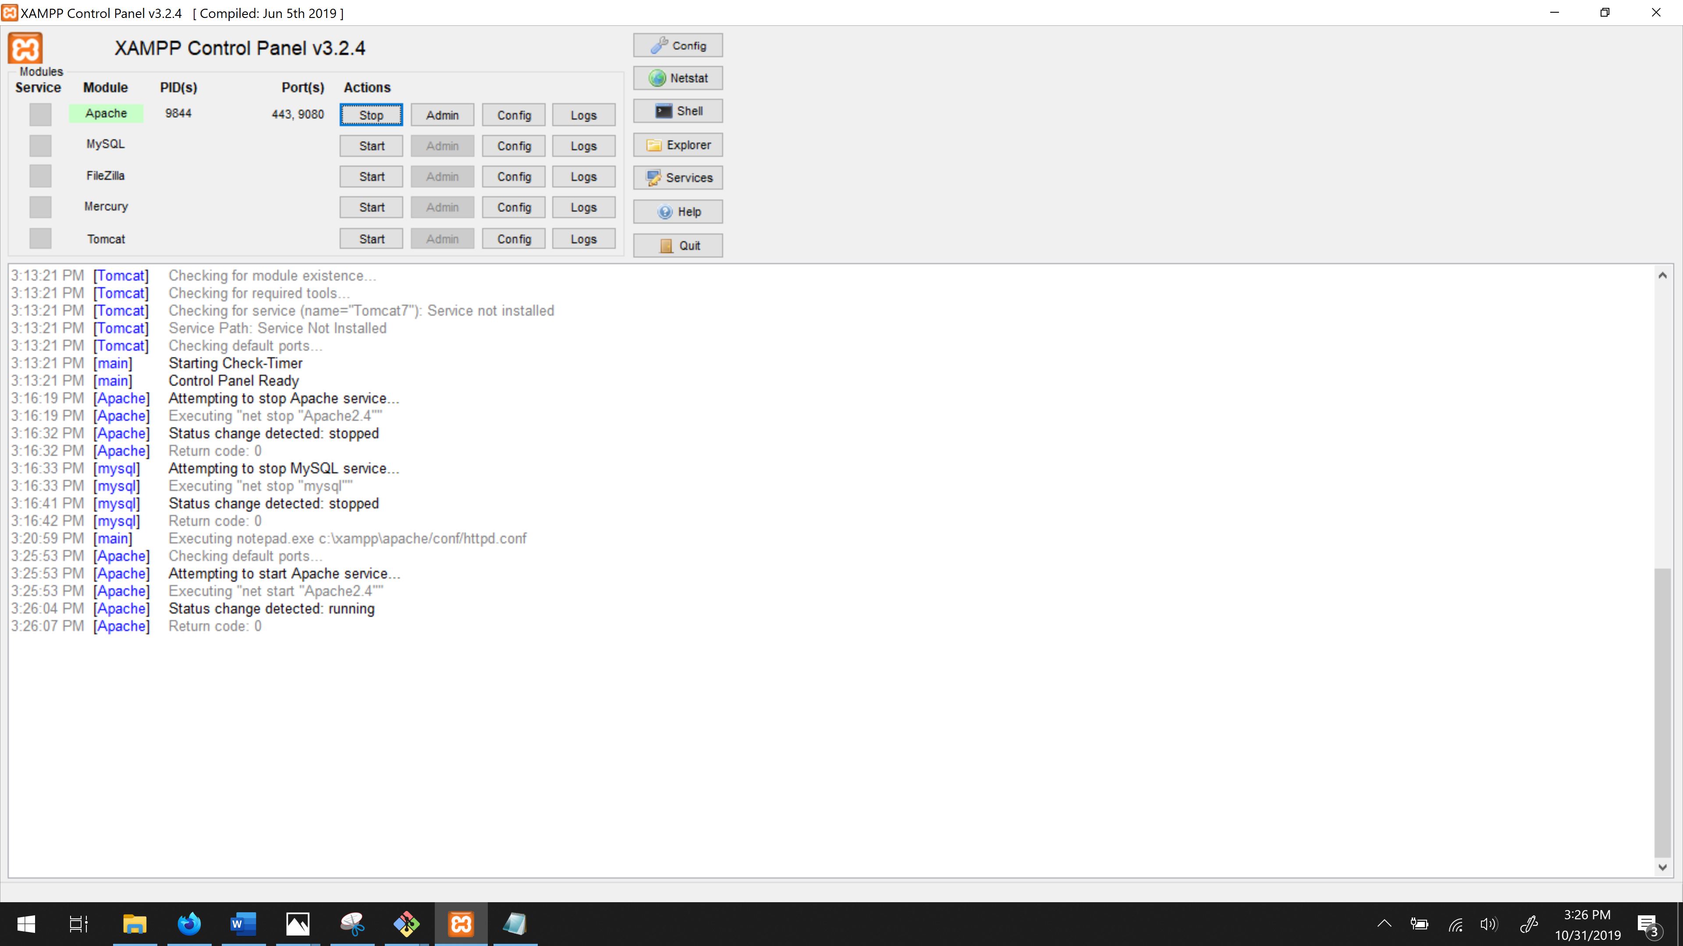

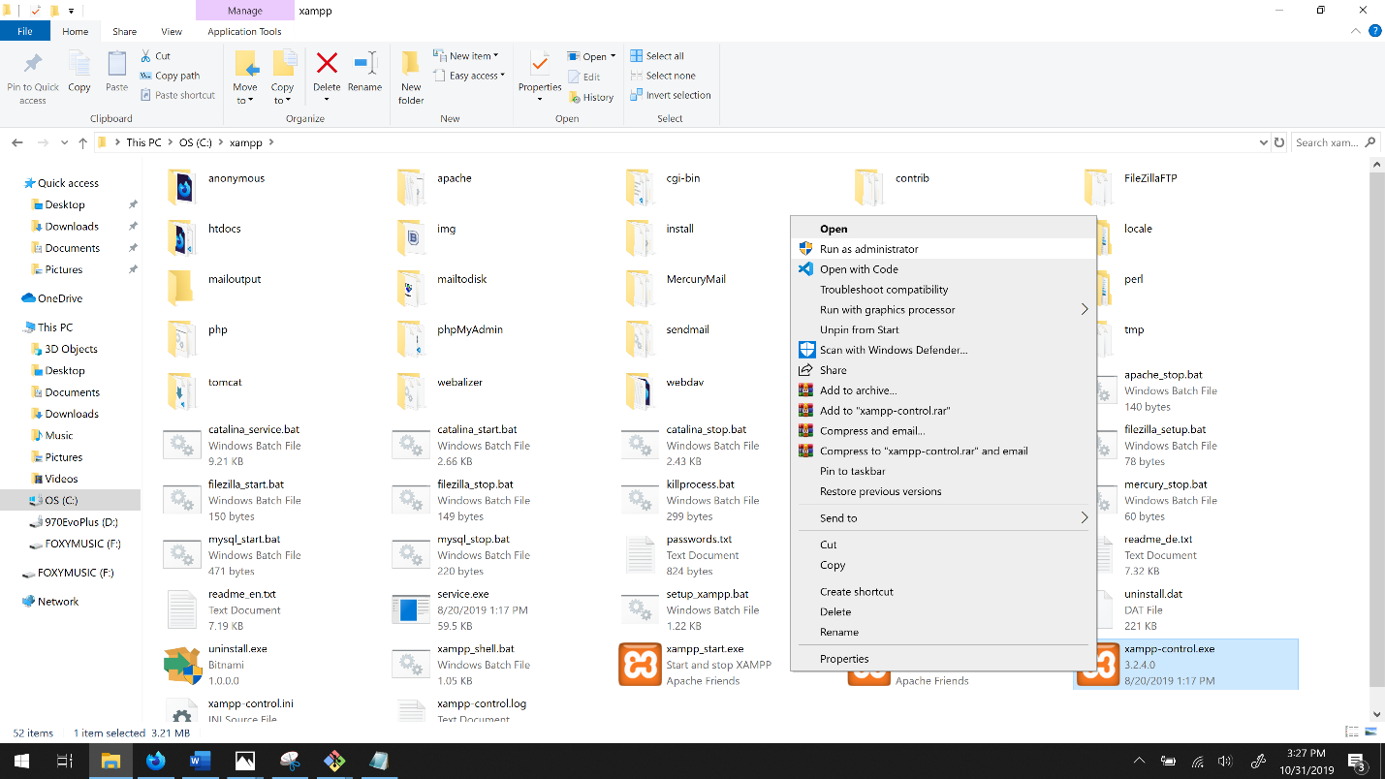

You will know if you are running as admin. because the box will be green-ticked.

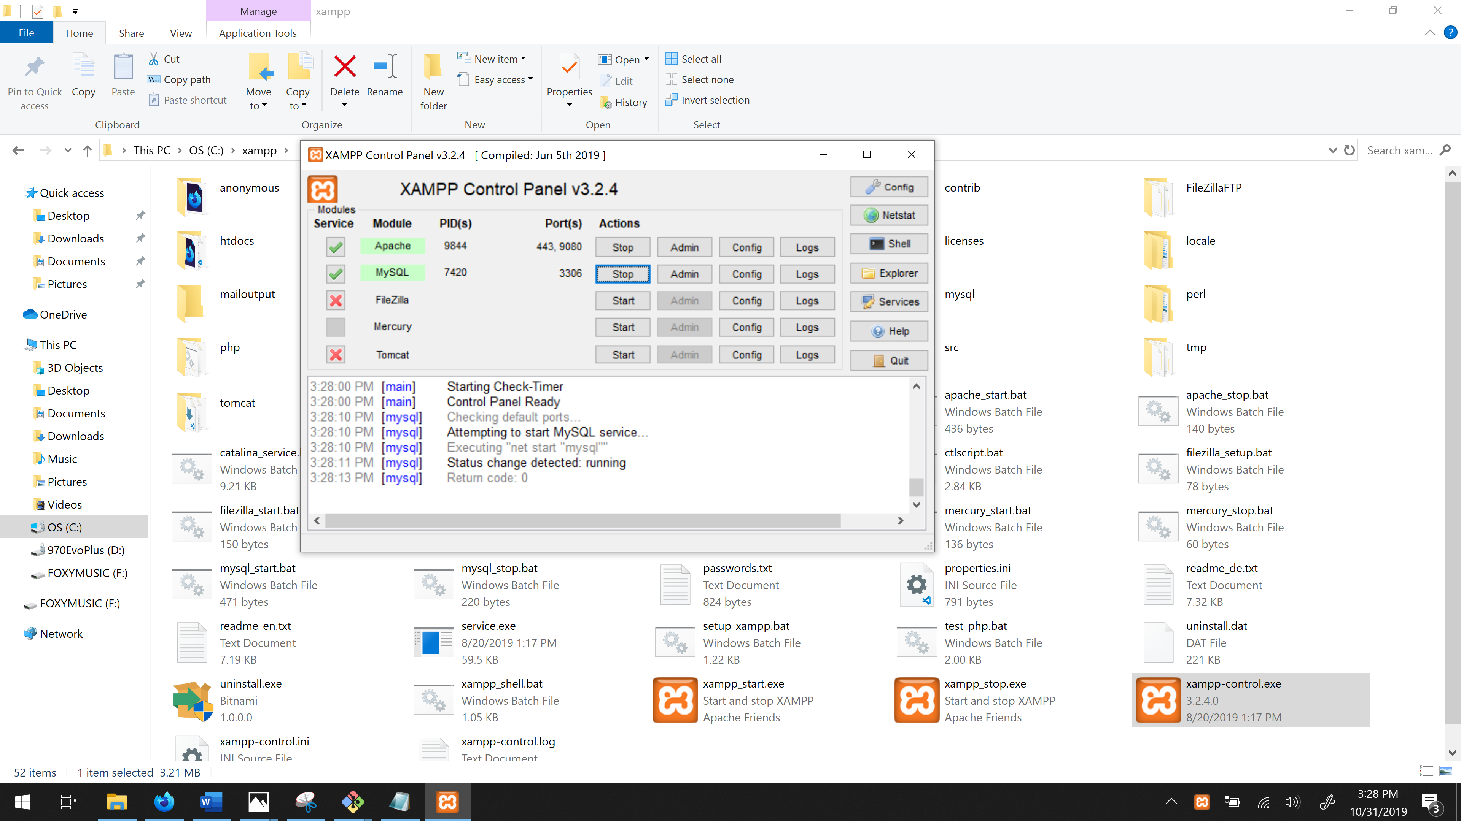

Step 29: start MySQL. You do not have to change anything in this.

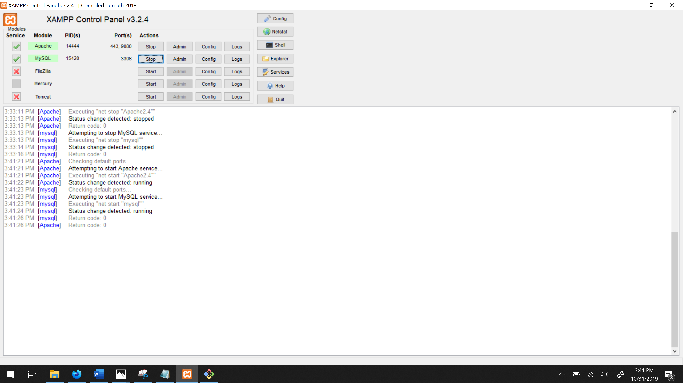

Step 30: Go to your .htacesss in located in your htdocs folder.

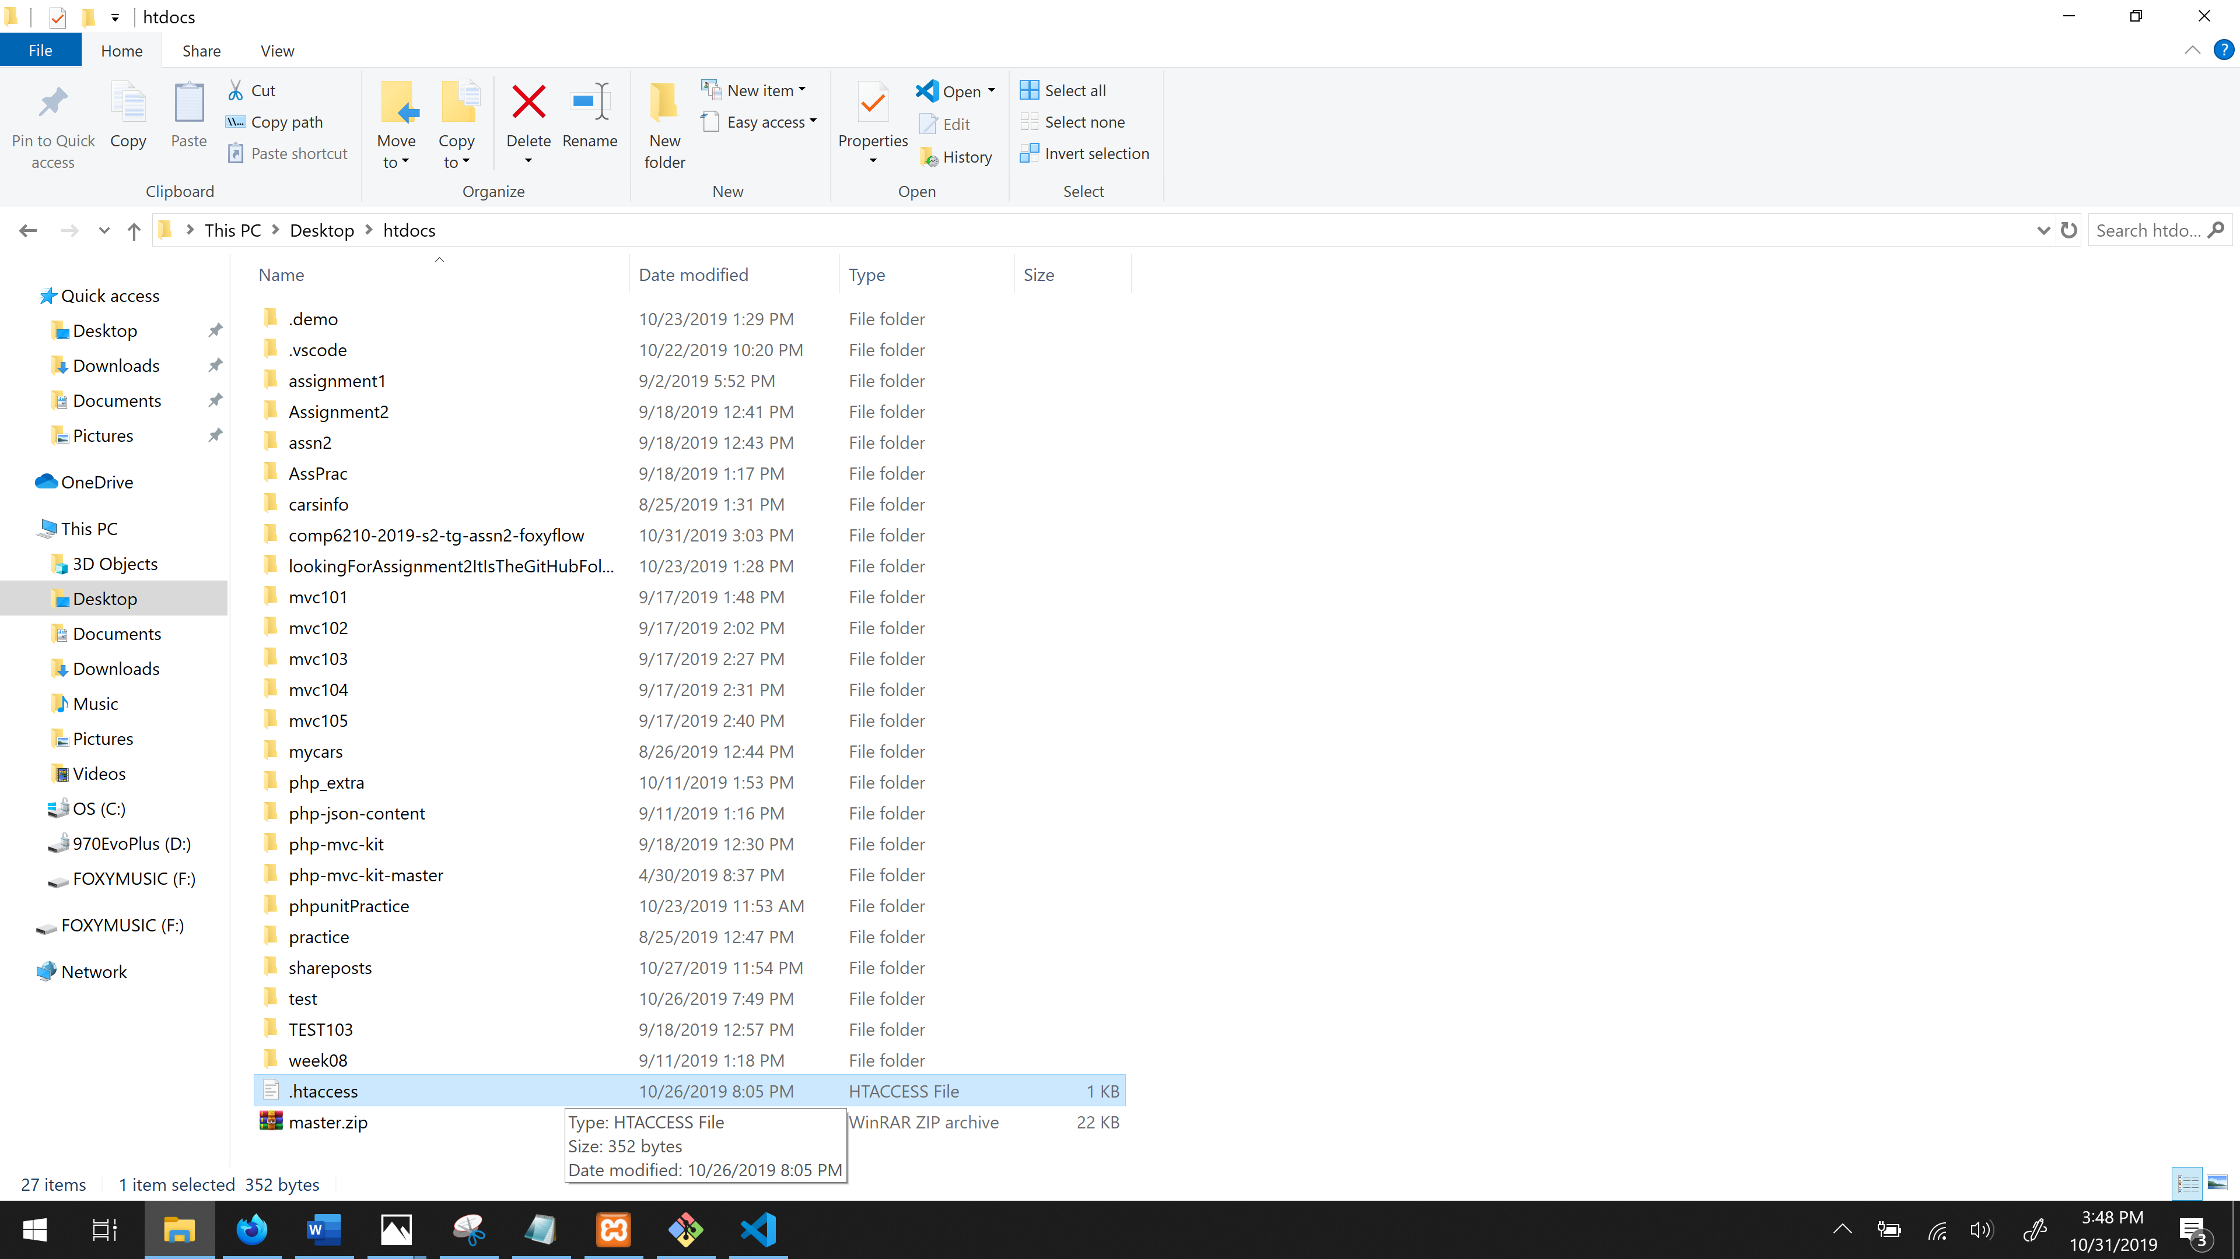

Type in: comp6210-2019-s2-tg-assn2-foxyflow/ (your lovely website folder name)

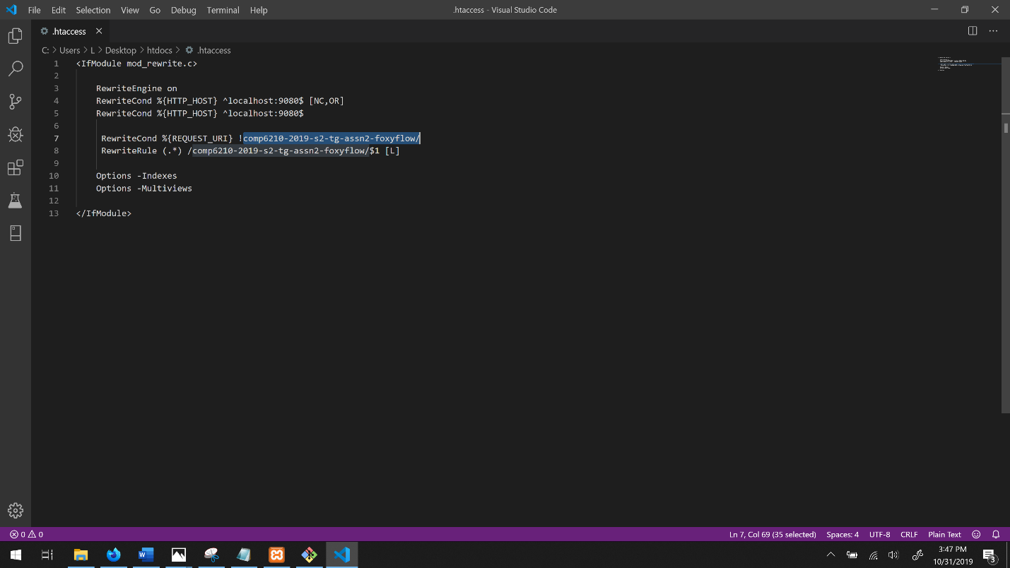

Make sure you have written it twice in the exact highlighted spot shown.

Now that you have a server on your computer and with the root directory accessible, the website should run.

Step 31: Have a look at the website: Type into your browser:

**Localhost:9080** and press enter. Here is your home page.

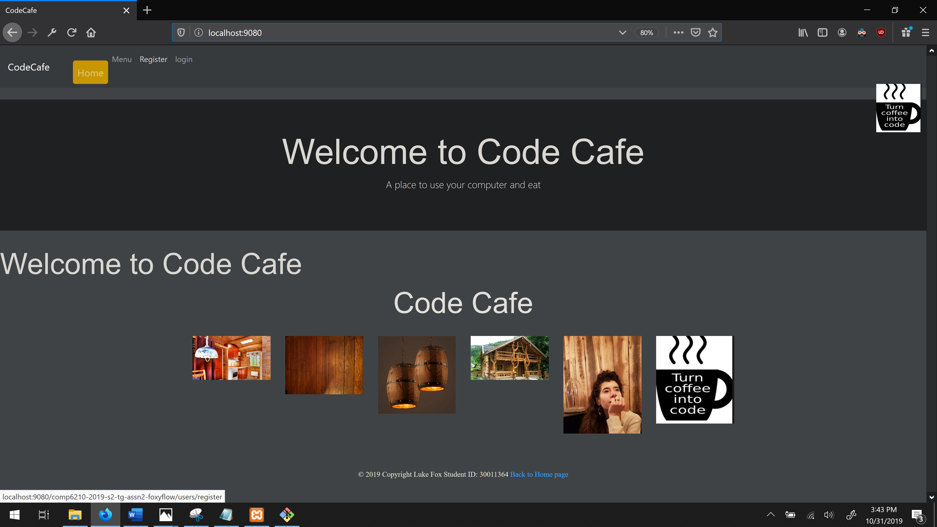

To register your details you must connect to the database (that comes with XAMPP).

Step 32: Setting up the database. Go to: localhost:9080/phpMyAdmin and click on **import**

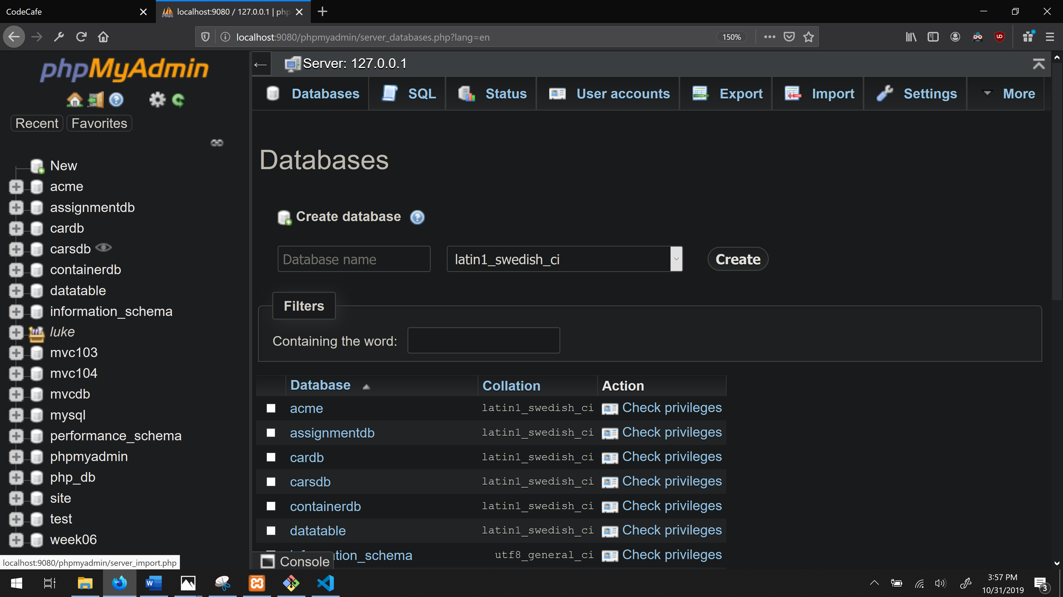



Step 33: Import the database (Click Browse)

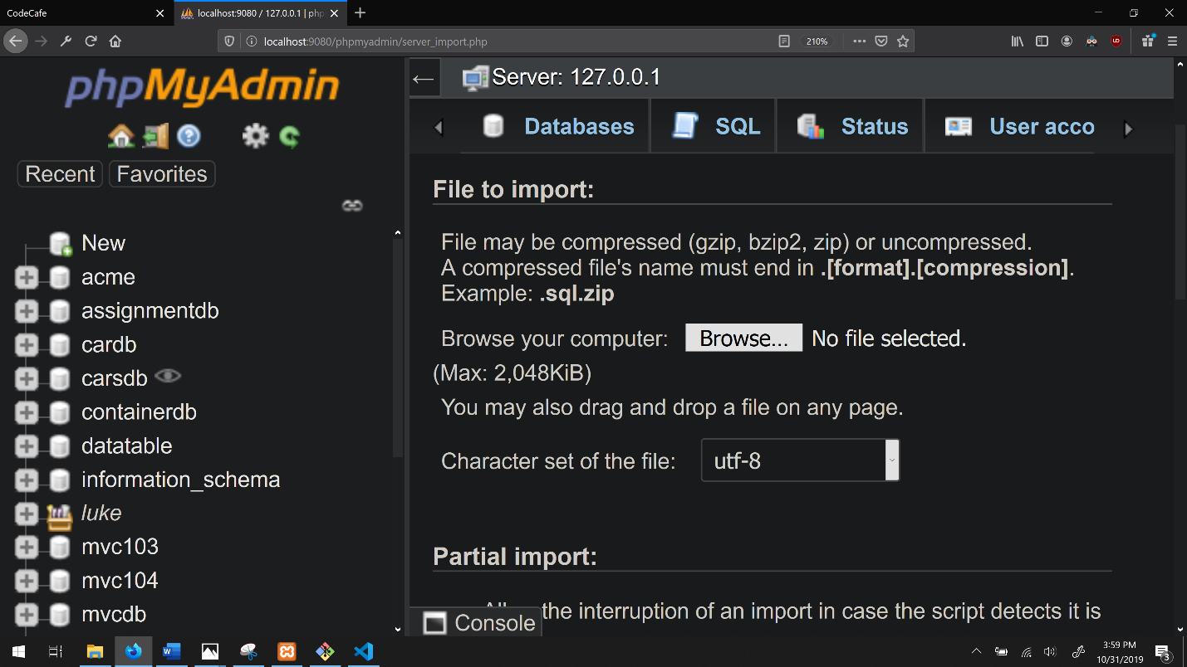

Go into your website folder/public/SQL … click on final.sql to open

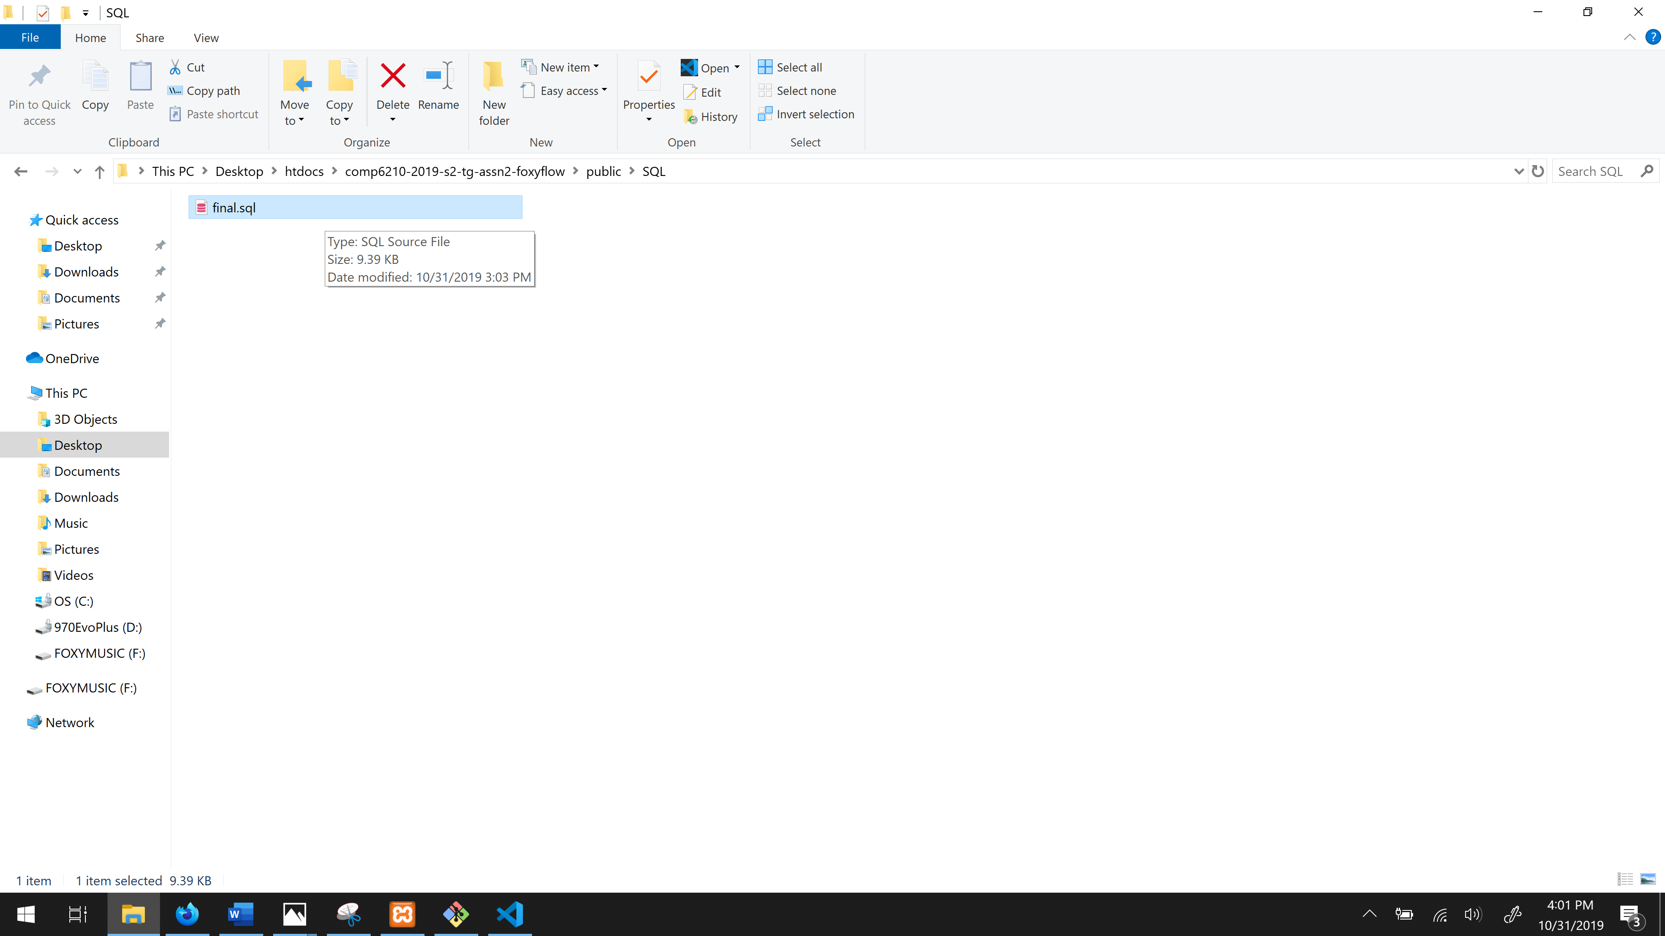

You should have final.sql loaded now. Then click Go.

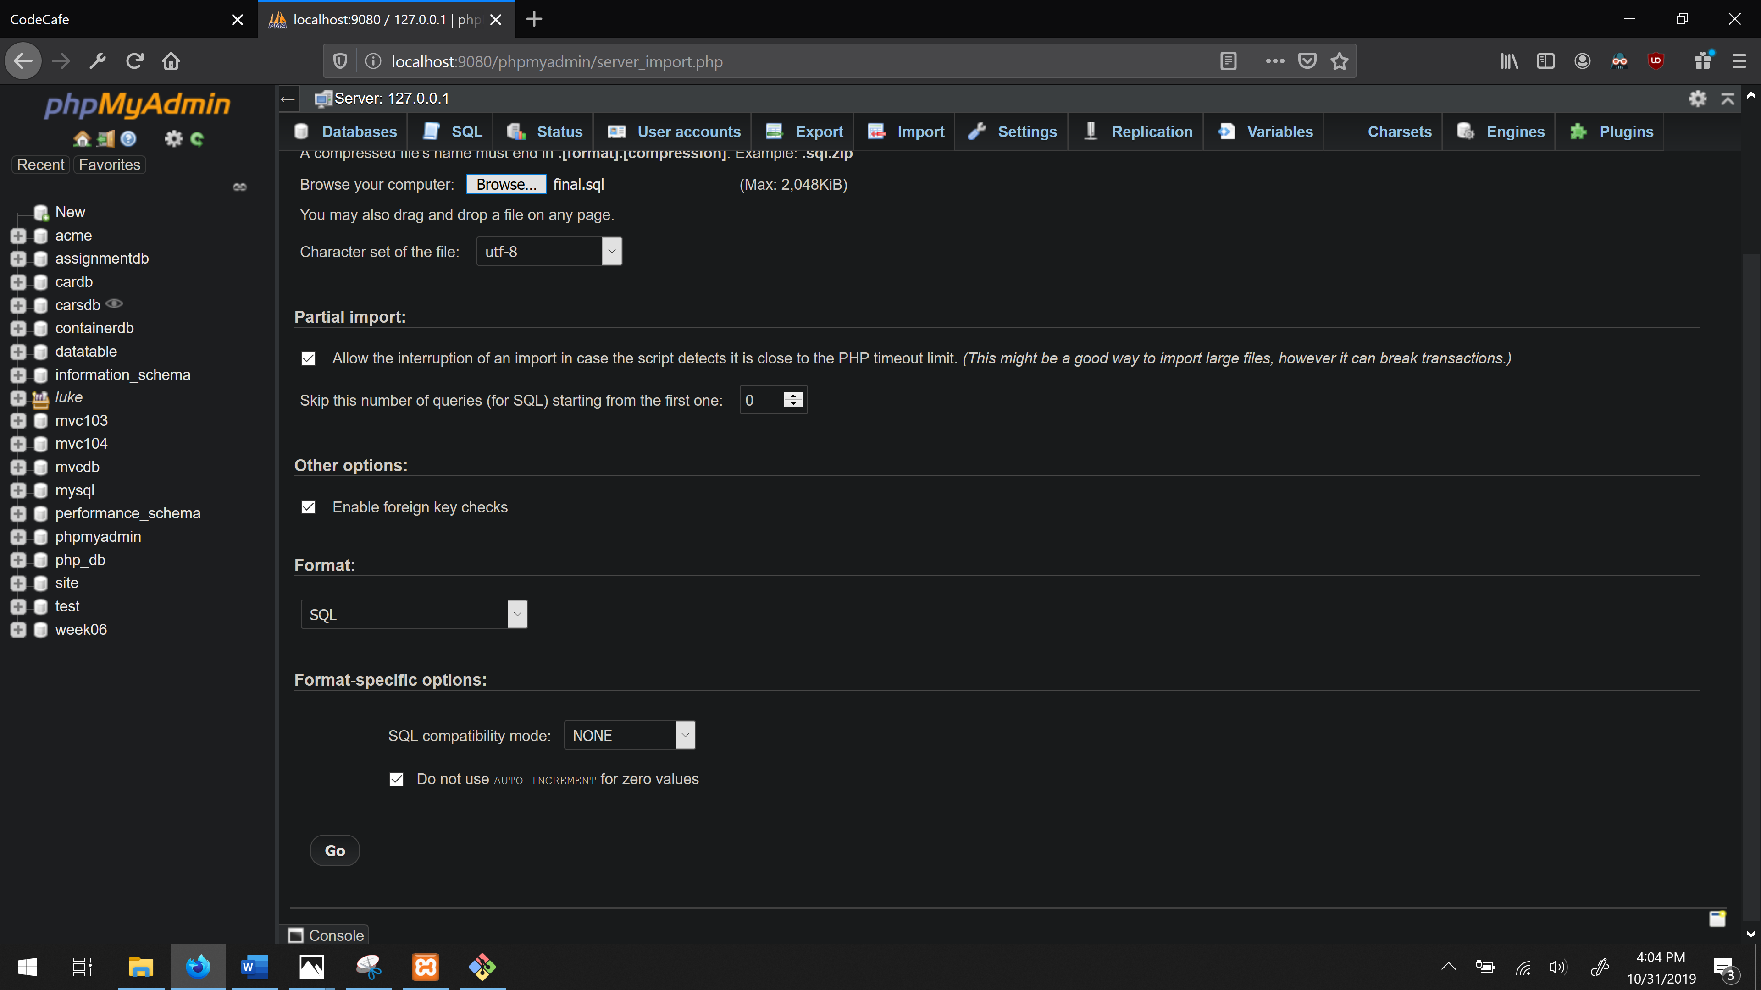



Now you should see the ‘final’ database installed

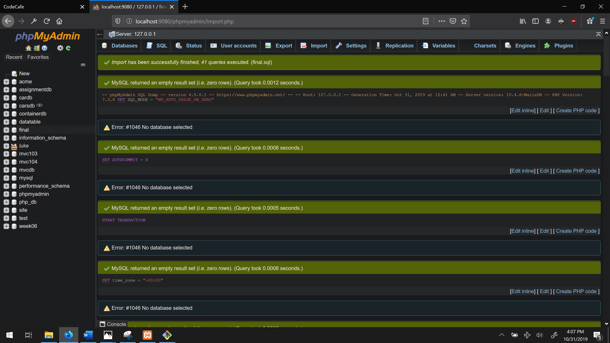



Now you can register your information and login and logout and your details will be stored in the ‘final’ database. Enjoy your Aglie website.